ALAI UP Dashboard Toolkit 1.0 Instructions
The ALAI UP Dashboard Toolkit 1.0 is a comprehensive set of tools and resources to help clinics monitor their long-acting injectable HIV treatment (LAI ART) programs. The Dashboard Toolkit can be used by clinic leadership, LAI ART program leads, data management and quality teams, and other stakeholders to:
- Track progress toward their implementation goals for their LAI ART program
- Identify gaps in LAI ART care delivery across different social determinants of health
- Guide efforts to address gaps and improve the quality of services for all clients

The ALAI UP Dashboard Toolkit 1.0 has been developed and optimized for monitoring injectable cabotegravir/rilpivirine (iCAB/RPV) delivery and will be adapted for other LAI ARTs.
The Dashboard Toolkit consists of a set of connected tools and associated user guides for using the ALAI UP Dashboard. Using the tools requires no programming knowledge or data sharing. All data stay local to the computer running the tools.
- Guide to Monitoring Long-Acting Injectable Antiretroviral Therapy (LAI ART) Delivery (start here)
- ALAI UP Client-Level Data Collection Tools
  - Data Preparation Guide – Instructions on how to prepare data for optimal use with the Dashboard
  - Data Dictionary – Variable names, descriptions, and valid responses
  - Data Template – Blank data collection template
- ALAI UP Data Validator Tools
- Data Validator User Guide – Instructions on how to use the Data Validator to check data for logic and completeness
- Data Validator – Link to the Data Validator
- ALAI UP Dashboard
  - Dashboard User Guide – Instructions on how to navigate the Dashboard and detailed descriptions of all dashboard pages
  - ALAI UP Dashboard – Link to the Dashboard
  - Simulated Dashboard Data – Synthetic dataset to be used for exploring the Data Validator and Dashboard functionality
Access the ALAI UP Dashboard Toolkit through www.alai-up.org.
STEP 1: Explore if the Dashboard is right for your clinic by reviewing the Guide to Monitoring Long-Acting Injectable Antiretroviral Therapy (LAI ART) and viewing the Dashboard with the Simulated Dashboard Data.
STEP 2: Prepare client-level data using the Excel-based Data Template, following instructions in the Data Preparation Guide and Data Dictionary.
STEP 3: Use the Data Validator Tool and follow the Data Validator User Guide to check data for logic and completeness. Edit data as necessary to generate a final analytic data set.
STEP 4: Upload cleaned clinic data onto Dashboard to track LAI ART implementation process, identify gaps in care, and guide quality improvement.

ALAI UP Dashboard Data Security
The Dashboard is a point-and-click program that does not require any programming knowledge or data-sharing to run. The Dashboard program code is written in R software using the shiny package. To make the tool more user friendly, ALAI UP has designed this program to run through standard internet browsers (e.g., Google Chrome, Microsoft Edge, Safari) using the shinylive package. Although the Dashboard program is accessed and run through internet browsers, clinic data are not saved, shared, or uploaded online at any time. Throughout the whole process of using the tool, clinic data stay local to the computer running these programs.
ALAI UP has made best efforts to ensure that the ALAI UP Dashboard Toolkit tools are secure. By design, data never leave a user’s computer, are never transmitted over the internet, and are never stored in a server. When a user loads the ALAI UP Dashboard webpage, a complete R Programming environment is set up in the browser, with all the necessary packages and files to run the Dashboard. All Dashboard computations take place within your browser, and the data are deleted when the user closes the browser tab. Additionally, the data may be fully deidentified by adjusting birth dates to just represent birth years without losing any dashboard functionality.
The Dashboard is written using the R programming language, using the shiny and shinylive packages. Shinylive is a way to run Shiny entirely in the browser, without any need for a hosted server, using WebAssembly via the webR project. It is deployed via GitHub Pages.

ALAI UP Dashboard Toolkit Funding Statement
The development of the ALAI UP Dashboard was financially supported by the Health Resources and Services Administration (HRSA), Department of Health and Human Services (HHS) Grant U1SHA46532. The award provided 100% of the total costs and totaled $7,450,000. The contents are those of the developers. They may not reflect the policies of HRSA, HHS, or the U.S. Government.

Table of Contents
ALAI UP Dashboard Toolkit 1.0 Instructions 1
ALAI UP Dashboard Data Security 2
ALAI UP Dashboard Toolkit Funding Statement 2
Guide to Monitoring Long-Acting Injectable Antiretroviral Therapy (LAI ART) Delivery 4
Motivation – Why monitor LAI ART delivery? 4
LAI ART Indicators – What should your clinic measure and monitor? 5
ALAI UP Dashboard – How can clinics use the Dashboard to monitor LAI ART delivery? 11
ALAI UP Client-Level Reporting Tools 15
A. Data Preparation Guide 15
B. Data Dictionary 27
C. Data Template 27
ALAI UP Data Validator Tools 27
D. Data Validator User Guide 27
E. Data Validator (link) 32
ALAI UP Dashboard 34
F. Dashboard User Guide 34
G. ALAI UP Dashboard (link) 68
H. Simulated Dashboard Data 69
Appendix 70
I. Appendix 1. ALAI UP LAI ART Core Indicators and Sub-Indicators 70

STEP 1: Explore if the Dashboard is right for your clinic by reviewing the Guide to Monitoring Long-Acting Injectable Antiretroviral Therapy (LAI ART) and viewing the Dashboard with the Simulated Dashboard Data.

Guide to Monitoring Long-Acting Injectable Antiretroviral Therapy (LAI ART) Delivery
This document describes the rationale for routinely and systematically collecting client-level data to monitor your clinic’s LAI-ART delivery, defines and recommends key clinical quality indicators of LAI ART delivery and describes how this data can be gathered and used to inform program decisions and support quality improvement.
ALAI UP recommends that clinics convene stakeholders early in the data monitoring process to review this guide and identify shared goals and available resources for monitoring.
Clinics planning to monitor their LAI ART program can consult the tools in the ALAI Dashboard Toolkit, which center around the (1) ALAI UP Guide to Monitoring Long-Acting Injectable Antiretroviral Therapy (LAI ART) Delivery , (2) ALAI UP Client-Level Reporting Tools, (3) the ALAI UP Data Validator Tools, and (4) the ALAI UP Dashboard.
- The ALAI UP Client-Level Reporting Tools provides a template for collecting analysis-ready data related to a clinic’s LAI ART program, starting with iCAB/RPV.
- The ALAI UP Data Validator Tools support the validation of analysis data for logic and completeness.
- The ALAI UP Dashboard allows for rapid visualization and analysis of the client-level LAI ART data, to support monitoring of LAI ART delivery, identification of care gaps, and opportunities for quality improvement.
The current ALAI UP Dashboard Toolkit 1.0 has been developed and optimized for monitoring injectable cabotegravir/rilpivirine (iCAB/RPV) delivery and will be adapted for other LAI ARTs.

Motivation – Why monitor LAI ART delivery?
The HIV Care Continuum is a well-established framework that clinics use to routinely collect, monitor, and report HIV care data. The HIV Care Continuum remains relevant in the current era of LAI ART, but new clinical and process indicators are needed for program monitoring of LAI ART delivery. Articulating the steps of LAI ART delivery, developing indicators to capture each step, and then monitoring outcomes related to the flow of clients through each step is critical for ensuring that clinics are achieving their LAI ART program goals and delivering LAI ART with quality.
In collaboration with our eight ALAI UP demonstration sites, the ALAI UP Monitoring, Evaluation, and Learning (MEL) Team developed the LAI ART Clinical Flow Framework, which describes a universal framework for how clients flow through the stages of LAI ART initiation, sustainment, viral suppression, and discontinuation (Figure 1).

Figure 1. ALAI UP LAI ART Clinical Flow Framework
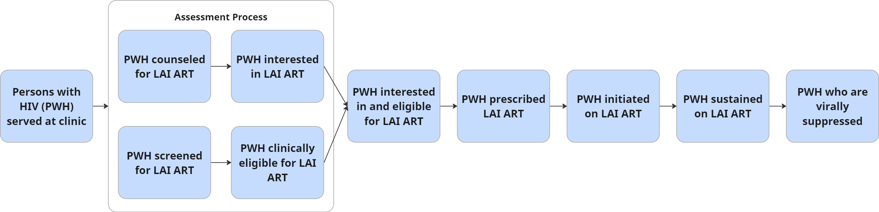
In the first step, people with HIV (PWH) are assessed for LAI ART, which consists of being educated about LAI ART and/or screened for LAI ART clinical eligibility. We established “assessed” as the first step in the flow because clinics differ in how they sequence (a) counseling clients about LAI ART, (b) determining client interest in LAI ART, and (c) screening for clinical eligibility. “Assessed” encompasses all of these steps, to enable comparisons across clinics and within clinics (as processes and workflows evolve) to establish a consistent first step. After clients are assessed, clients that are both clinically eligible for LAI ART and interested in initiating LAI ART are identified and prescribed LAI ART. After being prescribed, clients then initiate LAI ART by receiving their first loading dose. Clients are then placed on a dosing schedule to receive subsequent follow-up injections on a monthly- or bi-monthly dosing schedule; these injections can be delivered early (before the start of the injection window), on-time (within the injection window), or late (after the end of the injection window). Clients who remain on LAI ART are considered sustained, while some clients may choose to discontinue or need to discontinue due to treatment failure or emergent resistance. Clients who are sustained on LAI ART may achieve and then sustain viral suppression (if they initiated LAI ART with viremia) or sustain viral suppression (if they initiated LAI ART already virally suppressed).

LAI ART Indicators – What should your clinic measure and monitor?
Using the LAI ART Clinical Flow Framework, the ALAI UP MEL team identified five core indicators of LAI ART delivery that capture key steps within the LAI ART clinical flow. The ALAI UP MEL team posits that these five core indicators should be measured and monitored by clinics delivering LAI ART to ensure that clinics are achieving their LAI ART program goals and delivering LAI ART with quality.
These five core indicators are defined below and are featured on the ALAI UP Dashboard as components of the LAI ART Care Gap Analysis (Figure 2). Definitions of each bar are elaborated below, however it is important to understand that each bar represents the percent of the previous bar. Jumps or gaps between adjacent bars on the LAI ART Gap Analysis represent care gaps in LAI ART delivery that could be investigated and addressed by clinics. In addition to the five core indicators, ALAI UP identified and defined sub-indicators that influence performance on the core indicators and can explain care gaps. For additional details about the core indicators and sub-indicators, including numerator and denominator definitions, and the specific data elements and variables needed to calculate these indicators, please refer to Appendix 1 and the Data Dictionary.

Figure 2. LAI ART Care Gap Analysis

Note: Data represented in the LAI ART Care Gap analysis are synthetic data for illustrative purposes
Clinics are free to choose an appropriate time period to update data and calculate the indicator (e.g., 6 months) that makes sense for their clinic data review and quality improvement workflow. By default, the Dashboard shows the indicator for the entire timespan covered by the uploaded data, but the user can either upload data for a select time period or restrict the data analyzed in the Dashboard to specific years to allow for quality monitoring for a particular period or following the introduction of a change initiative.
A note about access to LAI ART: We acknowledge that at some clinics, it may already be known that a client’s HIV medication payor will not cover the cost of LAI ART (e.g., clinic is in a state where LAI ART is not on the ADAP formulary). In other scenarios, the LAI ART access barrier may only become apparent after the client is prescribed LAI ART and denied insurance coverage or eligibility for a patient assistance program (PAP).
In both scenarios, we encourage clinics to still evaluate the client for LAI ART clinical eligibility, and separately document (1) whether the client meets clinical eligibility for LAI ART, and (2) whether the client has access to LAI ART in the form of a payor that will cover the cost of LAI ART. Then, if clients are clinically eligible for and interested in LAI ART, we encourage clinics to prescribe LAI ART and then document the access barrier (see sub-indicator LAI ART Not Accessible below). Prescribing LAI ART to all clients who are clinically eligible for LAI ART will ensure that the access barrier is documented in the care gap analysis at the same step (between prescribed and initiated) and will allow clinics to accurately understand the root causes of care gaps.

Core Indicator 1: Percent Assessed for LAI ART
Definition: The proportion of clients counseled about LAI ART or screened for LAI ART clinical eligibility out of clients with HIV served at the clinic within a given time period.
Calculation:
$$Percent Assessed for LAI ART$$
$$=\frac{\# clients counseled about LAI ART or screened for LAI ART eligibility within a given time period}{\# clients with HIVserved at a clinic within a given time period}×100$$
Care gaps in percent assessed can occur when the percent counseled about LAI ART or percent screened for LAI ART eligibility are not optimal.
- Sub-Indicator 1a: Percent counseled about LAI ART is defined as the number of clients counseled about LAI ART out of the number of clients with HIV served at the clinic within a given time period.
- Sub-Indicator 1b: Percent screened for eligibility for LAI ART is defined as the number of clients screened for LAI ART eligibility out of the number of clients with HIV served at the clinic within a given time period.
Note: While clinics are encouraged to collect data on and monitor counseled and screened, the Dashboard has the capability to generate an LAI ART Care Gap Analysis that excludes the “assessed” core indicator *and counseled and screened sub-indicators) for clinics that only collect data on prescribing, initiating, and sustaining clients on LAI ART.

Core Indicator 2: Percent Interested in and Eligible for LAI ART
Definition: The proportion of clients interested in and eligible for LAI ART out of clients assessed.
Calculation:
$$Percent interested in and eligible for LAI ART$$
$$=\frac{\# clients interested in and eligible for LAI ART within a given time period}{\# clients counseled about LAI ART or screened for LAI ART eligibility within a given time period}×100$$
Care gaps in percent interested and eligible can occur when the percent interested in LAI ART or the percent eligible for LAI ART are not optimal. To understand and monitor reasons for these gaps, clinics should collect data on reasons clients are not interested in LAI ART and reasons clients are not eligible for LAI ART.
- Sub-Indicator 2a: Percent Interested in LAI ART is defined as the number of clients interested in LAI ART out of the number of clients counseled about LAI ART within a given time period.
  - Reason not Interested: ALAI UP recommends that clinics collect data on a common set of client reasons for not being interested in LAI ART and also consider clinic-specific reasons (see Data Dictionary for details).
- Sub-Indicator 2b: Percent Eligible in LAI ART is defined as the number of clients clinically eligible for LAI ART out of the number of clients screened for LAI ART eligibility within a given time period.
  - Reason not Eligible: ALAI UP recommends that clinics collect data on a common set of reasons for not being clinically eligible for LAI ART and also consider clinic-specific reasons (see Data Dictionary for details).
Note: Clinically eligibility criteria may vary by clinic. In particular, some clinics may consider clients who are not virally suppressed to be clinically eligible while other clinics may not. Use the criteria most relevant to your clinic to code this variable.
We discourage clinics from categorizing clients as not eligible if they are clinically eligible but do not have a payor that will cover the cost of LAI ART. Coding these clients as eligible but not initiated on LAI ART allows clinics to accurately document the care gap caused by payor access issues. Care gaps that result from payor access issues will be documented in the step between prescribed and initiated.

Core Indicator 3: Percent Prescribed LAI ART
Definition: The proportion of clients prescribed LAI ART out of clients interested in and eligible for LAI ART.
Calculation:
$$Percent Prescribed LAI ART$$
$$=\frac{\# clients prescribed LAI ART within a given time period}{\# clients interested in and eligible for LAI ART within a given time period}×100$$
Care gaps can occur when workflow issues (e.g. client interest in LAI ART not documented in EMR, client not screened for LAI ART eligibility despite interest in LAI ART) or provider hesitancy interrupt the flow from clients being identified as interested in and eligible for LAI ART and being prescribed LAI ART. ALAI UP has not identified any sub-indicators for Percent Prescribed LAI ART. However, clinics can consider their clinic workflow and identify possible sources of care gaps that could be monitored or processes that could be improved (e.g., time from when a client is identified as interested and eligible for LAI ART and prescribed LAI ART).
ALAI UP has identified one sub-indicator for Percent Prescribed LAI ART, described below.
- Sub-Indicator 3a: Percent accessible is defined as the number of clients able to financially access LAI ART out of clients prescribed LAI ART within a given time period.
  - Reasons not accessible: ALAI UP recommends that clinics collect data on a common set of client reasons for LAI ART not being financially accessible and also consider clinic-specific reasons (see Data Dictionary for details).

Core Indicator 4: Percent Initiated on LAI ART
Definition: The proportion of clients initiated on LAI ART (receiving at least 1 injection) out of clients prescribed LAI ART.
Calculation:
$$Percent initiated on LAI ART$$
$$=\frac{\# clients initiated on LAI ART within a given time period}{\# clients prescribed LAI ART within a given time period}×100$$
Care gaps can occur when access issues (e.g., insurance denial, LAI ART not on payor formulary) or workflow issues (e.g., clinic is at capacity for clients on LAI ART or has instituted a waitlist) interrupt the flow from clients being prescribed LAI ART and receiving their first injection. Some clients may also change their mind about initiating LAI ART or may want to wait to initiate. To understand and monitor reasons for these gaps, clinics should collect data on the reasons clients do not initiate LAI ART after being prescribed, specifically, what percent of clients do not have access to LAI ART despite being clinically eligible, interested, and prescribed.

Core Indicator 5: Percent Sustained on LAI ART
Definition: The proportion of clients sustained on LAI ART (still receiving LAI ART) out of clients initiated on LAI ART.
Calculation:
$$Percent sustained on LAI ART$$
$$=\frac{\# clients sustained on LAI ART within a given time period}{\# clients initiated on LAI ART within a given time period}×100$$
Care gaps can occur when injections are not delivered on time, clients develop viral resistance, clients fail treatment, or clients are lost to follow up. Clients can also discontinue LAI ART for other non-clinical reasons, which clinics should monitor as well.
- Sub-Indicator 5a: Percent On-Time Injection is defined as the number of maintenance injections (i.e. non-loading dose injections) administered within +/- 7 days of target treatment date out of all maintenance injections. Note: This definition of on-time injection is operationalized for iCAB/RPV delivery, but can be adjusted for other LAI ART formulations.
- Sub-Indicator 5b: Percent with Treatment Failure is defined as the number of clients on LAI ART with (1) 1 VL >1000 copies/mL, or (2) 2 consecutive VL >200 copies/mL, or (3) emergent resistance at a given time since initiating LAI ART out of all clients on LAI ART.
- Sub-Indicator 5c: Percent Lost to Follow Up is defined as the number of clients on LAI ART who did not receive a maintenance injection for >90 days, or who are indicated as “discontinued” with the reason being lost to follow up, out of all clients on LAI ART. Note: This definition of lost to follow up is operationalized for iCAB/RPV delivery, but can be adjusted for other LAI ART formulations.
- Percent with Other Reasons for Discontinuation: ALAI UP recommends that clinics collect data on a common set of reasons for discontinuing LAI ART and also consider clinic-specific reasons (see Data Dictionary for details).

ALAI UP Dashboard – How can clinics use the Dashboard to monitor LAI ART delivery?
This section is intended to give an overview of how clinics can use their HIV care data and the LAI ART core and sub-indicators to monitor their LAI ART program.

Identifying Care Gaps
First, we recommend that clinics review their LAI ART Care Gap Analysis (see Figure 2). This analysis provides an overview of the five core LAI ART indicators. Reviewing the indicators can help your clinic identify gaps in your LAI ART care delivery where your clinic may want to set targets to improve performance, set targets to maintain performance, or get curious and investigate certain process or clinical outcomes.
For example, if the percent Assessed for LAI ART interest and eligibility is surprising, a clinic could investigate which clients are not being educated about LAI ART or screened for clinical eligibility, and why?
If there are gaps in the percent of clients Eligible and Interested in LAI ART, a clinic could investigate whether this is because clients are not interested in LAI ART, not eligible for LAI ART, or both. If interest in LAI ART is low, it can be valuable to also collect information on why clients are not interested in LAI ART and whether these factors are modifiable with new clinic policies (e.g., client cannot attend frequent clinic visits during business hours but could come during evenings and weekends), or client education (e.g., client is worried medication is too new and experimental), or whether they reflect client preferences (e.g., client is happy with current medication and/or does not like needles). Similarly, if many clients are found to be clinically ineligible, a clinic could examine whether LAI ART could still be appropriate (e.g., a client who is not virally suppressed because they cannot swallow pills but never misses a clinic appointment).
If there are gaps in percent Prescribed LAI ART, a clinic could examine whether there are workflow issues (e.g., is client interest documented in EMR so next steps can be taken? Is there follow up for clients who are “maybe interested”). Another possibility could be that providers are hesitant to prescribe LAI ART to certain clients despite client interest and clinical eligibility. In this scenario, a clinic could consider how to address provider concerns.
If there are gaps in percent of clients Initiated on LAI ART, a clinic could examine whether there are access issues preventing clients from initiating on LAI ART. For example, a clinic may be unable to access LAI ART for the client’s payor type (e.g., the clinic can only process pharmacy benefits, not medical benefits or vice versa), LAI ART may not be on a payor’s formulary (e.g., LAI ART is not on some ADAP formularies), additional payor paperwork may be required (e.g., prior authorization, appeals), or there could be clinic workflow issues (e.g. delays submitting to insurance or appealing denials). A clinic may also impose waitlists to manage workload or a client may have changed their mind about initiating LAI ART between being prescribed and the first injection.
Lastly there could be gaps in the percent of clients Sustained on LAI ART. If so, a clinic could examine whether clients are discontinuing due to issues with on-time injections, the emergence of viral resistance, or treatment failure, and could examine whether clinic policies could be adjusted to support clients attending clinic visits. Discontinuation could also be due to non-clinical reasons like a change in client preferences, clients leaving the clinic, or clients changing insurance. Investigating and understanding the underlying causes for these gaps can help a clinic set goals, allocate resources, and monitor their LAI ART program for quality.

Disaggregating Data
A key feature of the Dashboard is the ability to disaggregate LAI ART indicators by demographics and social determinants of health. This makes it possible to identify gaps in care and opportunities for quality improvement within groups of interests. Disaggregation variables include:
- Age
- Sex
- Ethnicity
- Race
- HIV-related behaviors (transmission risk category)
- HIV medication payor
- Poverty level
- Immigration status
- Primary language
- Incarceration status
- Housing status
- Employment status
- Recent CD4 result
- Site (if multiple sites)
- Additional SDOH (manually input)
For example, if a clinic wanted to ensure that counseling about LAI ART was reaching all of their clients and was concerned that information about LAI ART was only being delivered to clients with a certain payor type, they could look at what proportion of clients were counseled about LAI ART, by HIV medication payor type.
In Figure 3 below, we present what such a disaggregated analysis could look like. The dotted line in the figure identifies the overall average percent of clients assessed for LAI ART. Bars that extend to the right of the dotted line identify groups that are assessed about LAI ART at a proportion above average and bars that don’t reach the dotted line identify groups that are assessed at a proportion below average. Gray bars highlight groups with fewer than 10 clients, indicating findings should be interpreted with additional care (in this case all groups have >10 clients). Notice how the percent of clients assessed for LAI ART is higher for those aged 18-24 (82%) and lower for those aged 55-64 (53%) and 65+ (54%).
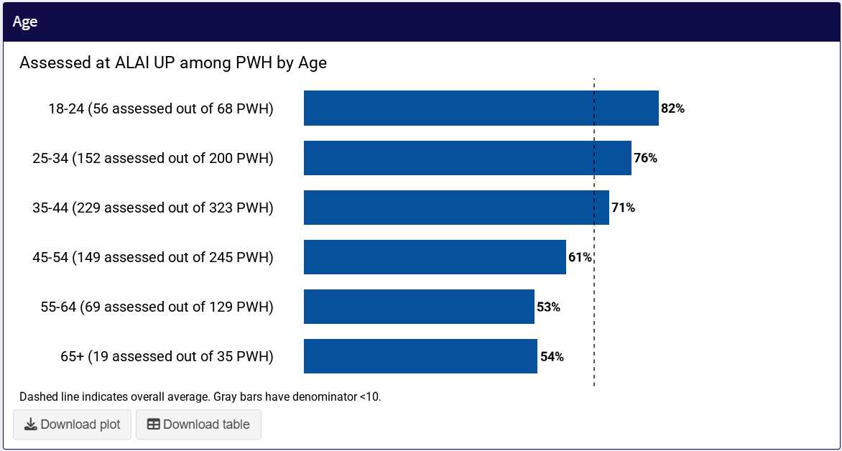

Setting Targets and Learning from Data
After implementing and monitoring indicators, a clinic may identify a care gap. Sometimes, in response to identifying that care gap, a clinic may decide to set a target to aspire to. For example, if a clinic identifies that 80% of their clients have been counseled about LAI ART, they could decide that they want to prioritize client education about treatment options and set a target that 95% of clients have been counseled about LAI ART. Another scenario could be that a clinic identifies that overall, 80% of clients have been counseled about LAI ART, but that when they disaggregate their data by groups, 100% of Group A have been counseled about LAI ART but only 50% of Group B have been counseled about LAI ART. The clinic could set a target that 95% of clients within groups are counseled about LAI ART. Setting a target about percent of clients counseled about LAI ART is appropriate because this process outcome is within the control of the clinic. Other times, safety indicators like on-time injections, emergent resistance, viral failure, and clients being lost to follow-up may not be entirely in control of the clinic, but a clinic may still want to set performance and safety targets and investigate if those targets are not being met.
As another example, a clinic may identify that while 80% of Group A is interested in LAI ART, only 30% of Group B are interested in LAI ART. In this situation, a clinic could get curious about their data and ask: What are some reasons that members of Group B are not interested in LAI? Are there barriers or misinformation specific to Group B that the clinic could address? It would be inappropriate for a clinic to set a target for an indicator like client interest in LAI ART, which depends on a client’s preference. However, clinics can benefit from understanding possible underlying reasons for gaps and differences across groups.
Setting targets | Learning from data
100% of Group A has been counseled about LAI ART vs 50% of Group B  Target: >95% of all PWH are counseled about LAI ART | 50% of Group A are interested in LAI ART vs 5% of Group B  Question: What are some reasons Group B not interested? Are there barriers or misinformation specific to Group B to address?

In sum, collecting individual level data about an LAI ART program can help a clinic monitor the program for quality and inform where a clinic might want to focus their attention and resources. We propose some key indicators that we used in the ALAI UP Project to monitor LAI ART delivery and program growth, that clinics can adopt in their own LAI ART programs. Rather than make program decisions based on intuition, these indicators can help clinics ground decisions in data and advocate for more resources when needed. Lastly, it is important to recognize that LAI ART interest, eligibility, access and clinical outcomes can differ, sometimes substantially, across groups. Thus, it’s important to not only look at these indicators overall for a clinic, but also to stratify data into meaningful groups who may have different experiences to ensure that all clients at a clinic are receiving the highest quality of care.

STEP 2: Prepare client-level data using the Excel-based Data Template, following instructions in the Data Preparation Guide and Data Dictionary.

ALAI UP Client-Level Data Collection Tools

Data Preparation Guide
Overview and Purpose
This Data Preparation Guide is intended to support clinics in Step 2 of the Toolkit, the preparation of client-level data for use with the ALAI UP Dashboard. Note that with the exception of the Guide to Monitoring Long-Acting Injectable Delivery, tools in the ALAI UP Dashboard Toolkit are currently optimized for monitoring iCAB/RPV delivery specifically. However, Dashboard tools can be adapted to incorporate other LAI ART modalities. Please contact alai_up@cumc.columbia.edu for more information.
For more information on the specific indicators, how they are calculated, the rationale for monitoring them, and how to best make use of them, refer to the Guide to Monitoring Long-Acting Injectable Antiretroviral Therapy (LAI ART) Delivery.
Once your clinic’s data are prepared using the Client-Level Collection Tools, you are ready to move on to Step 3, using the Data Validator Tool to check your data for logic and completeness, and Step 4, uploading your final data set to the ALAI UP Dashboard.
Computing and Data Sharing Requirements
The ALAI UP Data Validator and ALAI UP Dashboard are point-and-click programs that do not require any programming knowledge or data-sharing to run. The Data Validator and Dashboard programs were written in the R software language using the shiny package to create the Dashboard. To make the Data Validator and Dashboard Programs more user friendly, ALAI UP has deployed these programs to run through standard internet browsers (e.g., Google Chrome, Microsoft Edge, Safari) using shinylive, another software package.
Although the Data Validator and Dashboard programs are accessed and run through internet browsers, clinic data are not saved, shared, or uploaded online at any time. Throughout the whole process of using the Data Validator and Dashboard, clinic data stay local to the computer running these programs.
Data security
ALAI UP has made best efforts to ensure that these tools are secure. Using the Data Validator Tool and Dashboard does not require data to ever leave your clinic’s computer system and data are never transmitted over the internet. In order to maintain security of the tools and data, please follow these data security best practices:
- Never share a completed Data Template outside of your organization unless there is an executed Data Use Agreement allowing for the sharing of client-level data with appropriate deidentification, encryption, or data security.
- Ensure emails with client-level data are encrypted.
- Follow your organization’s best practices for avoiding phishing and other hacking attempts.
Instructions
Step 1: Review the Data Dictionary and map all of the variables (based on their definition) to variables in your clinic’s database. Identify whether there are any variables that are not collected, are not accessible, or not easily extractable. After reviewing these instructions, consult Table 1. Data Template Variables (below) and run the simulated data in the Dashboard to understand how specific variables are used in the Dashboard. Next, decide which missing variables are high, medium, and low priority variables to obtain to ensure optimal Dashboard usability for your clinic’s needs. Finally, make a plan to obtain the data for the high-priority variables, which may require convening with stakeholders at your clinic to identify resources for obtaining this data.
Importantly, there are very few variables that are essential for the Dashboard to run. We encourage clinics to consider their resources and capacity to determine which indicators are (1) highest priority to monitor, and/or (2) which data are easiest to compile, and start there. Monitoring and evaluation capacity can be built over time, and data can be added to the Dashboard over time. For example, it may be that the data most available to clinic are injection dates and injection dose. A clinic could input only these data and a client identifier into the Data Template to use the Dashboard to monitor for on-time injections.

Step 2: Enter client-level data into the Data Template, which is an Excel file data template. Based on your clinic’s data infrastructure and database capabilities, data can be extracted automatically from electronic medical records (EMR), entered manually by staff, or a combination of both strategies.
Note that data can be entered and updated in the Data Template at any frequency/cadence that works for your clinic’s workflow. ALAI UP recommends updating the Data Template and reviewing the data in the Dashboard at least twice per year to support monitoring of LAI ART delivery that is based on recent events.
To transfer data from clinic-specific medical record databases and other data repositories, clinics should develop a data abstraction process based on the following considerations:
- Clients included in data set: Data sets prepared for the Dashboard should ideally include data for all clients with HIV served at your clinic since you began to offer iCAB/RPV. Including only clients who have been educated about or screened for LAI ART, or who have initiated LAI ART will limit the functionality of the Dashboard.
- Organizations with multiple locations: If your organization has multiple locations, delineate clients by site using the ‘site’ column. Ensure that each site has a consistent, unique name. If your organization only has 1 location, this field can be left blank.
- Transposing data for wide format: The Data Template uses a “wide” format for the data, meaning that each row represents 1 client. There are repeated columns for events that occur repeatedly or change over time, like iCAB/RPV counseling encounters and iCAB/RPV screening encounters, viral load measurements, and iCAB/RPV injections.
  - Depending on how data are exported from the clinic's EMR, it may take some time and effort to transform data exported on a “long” format into a wide format. Fortunately, this is a common task in many data manipulation tools. Look for how to "pivot" data in R, Python, and Excel, "transpose" in SAS, "reshape" in STATA, or "restructure" in SPSS.
- Naming columns/variables in data set: Take care that the prepared column names in your data set match the column names in the Data Dictionary and Data Template. The column order in which the data are entered into the Data Template does not impact Dashboard functionality.
- Adding additional columns/variables required by Dashboard: If needed, more columns for required template data can be added (e.g., viral load, injections, counseling dates). Make sure that the new columns follow the same naming conventions, and that the correct number is used.
  - Example: For viral load test results, the format follows "hiv_vl_10_result" and "hiv_vl_10_date". If and when more columns are needed, add them as "hiv_vl_11_result" and "hiv_vl_11_date". Ensure that the letters, capitalization, and use of the underscore ("_") are the same, and that the number is incremented correctly. Do not skip or reuse numbers.
- Adding additional columns/variables not required by Dashboard: If you are using the Data Template to collect your LAI ART data in real-time, and it is beneficial to your clinic’s workflow to add additional columns not required by the template, you may do so. Additional columns will be ignored by the Dashboard and will not impact functionality, as long as the column name is unique and is not shared by a column already in the template.
- Missing values: Missing values can occur for various reasons. At the clinic-level, data may be missing because those data are not routinely collected. At the client-level, data may be missing due to incomplete data entry, lost files, and many other reasons. A value may be missing if a measurement was not conducted (e.g., data not recorded in EMR, lab not ordered or equipment malfunctions), or a value may be missing when a measurement was conducted, but the data are not stored or easily accessible. All missing data are treated similarly and are ignored by the data tools. However, to support greater understanding of the source of missingness, a clinic could use the following rules:
  - For data that are not collected for any clients, leave the fields blank.
  - For data that are collected but may be missing (e.g. an unknown VL test result), use “UNK”.
- De-identification of data: If the data set being generated will only be used with the Data Validator Tool and the Dashboard, de-identification is optional. The column “uid” is required, but any unique identifier will work (e.g. MRN). Other identifying variables may be added as additional columns for convenience, but each row must have a unique ID.

Sites should additionally follow the below variable-specific guidelines:
The following table includes additional guidelines for each variable in the Data Dictionary, specifically how it is used in the Dashboard and guidance on valid response options. Please refer to the Data Dictionary for complete variable definitions and coding.
Variables required for basic Dashboard functionality are indicated below. However, all variables collected in the Data Template are used in the Dashboard, and fully completing the Data Template for all variables and for all clients with HIV on ART is encouraged if the data are available.

Table 1. Data Template Variables: Description and Functionality in Dashboard
Variable Name (column name) | Comments | Required for Basic Dashboard Functionality (yes/no)
Site (site) | If your organization has multiple sites, include this variable so that you can filter the Dashboard to see indicators across your whole organization or by site. Including site also allows you to view indicators stratified by site. If there are multiple sites, ensure that there is a unique, consistent name for each site. If you only have 1 site, leave blank or provide the name. | No
Unique ID (uid) | There should be 1 row for each unique ID. You may use MRNs as the UID. | Yes
ZIP code (zip_code) | This is used to create a map of all clients on ART by zip code and a map of LAI ART clients by zip code. | No
Vital status (vital_status_alive) | This is used to filter clients by vital status in Dashboard. | No
Birth date (birth_date) | Birthdate is used to calculate the client’s age on the date that the Dashboard is run. Age is a disaggregation variable in the Dashboard. Inclusion of this variable allows for indicators to be disaggregated by age.  For de-identification purposes, you may choose to provide only the birth year, with a generic date specified (e.g., 1/1/1990). | Yes
Ethnicity (ethnicity_hispanic) | This is a disaggregation variable in the Dashboard. Inclusion of this variable allows for indicators to be disaggregated by ethnicity. | Yes
Race (race_ai_an; race_asian; race_black; race_nh_pi; race_white; race_other; race_other_specify) | This is a disaggregation variable in the Dashboard. Inclusion of this variable allows for indicators to be disaggregated by race. | Yes
Sex (sex) | This is a disaggregation variable in the Dashboard. Inclusion of this variable allows for indicators to be disaggregated by sex. | Yes
Active year (active_20XX) | By default, the Dashboard shows all clients in the client-level reporting tool. A clinic may want to filter what data are shown in the Dashboard by which clients were active in a given year. This may be helpful for comparing historical data to current data, or if there is a high level of turnover at your site.  Clinics can define and code this variable however makes sense for their clinic. For example, a clinic could define and code a client as being active in a given year if they had any clinic visits, any laboratory results, any injection, or any prescriptions.  To add future years, follow the same naming format; the Dashboard will detect the years automatically. | No
HIV-related behaviors  [transmission risk category] (risk_msm; risk_idu; risk_heterosex;) | This is a disaggregation variable in the Dashboard. Inclusion of this variable allows for indicators to be disaggregated by HIV transmission risk category. | No
Health care coverage (health_care_coverage) | This variable is combined with secondary payor to become “HIV medication payor”, which is a disaggregation variable in the Dashboard. Inclusion of this variable allows for indicators to be disaggregated by HIV medication payor | Yes
Secondary payor (secondary_payor) | Secondary payor of HIV medications, if different or supplemental to health care coverage. These two variables are combined to create the “HIV medication payor” variable.  For example, if a client is uninsured but pays for HIV medications via ADAP, then their health care coverage should be “uninsured” and their secondary payor should be “ADAP”.  If a client has private insurance but also uses PAP to help cover the costs of HIV medications, their health care coverage should be “private insurance” and their secondary payor should be “PAP”. | No
Housing status (housing_status) | This is a disaggregation variable in the Dashboard. Inclusion of this variable allows for indicators to be disaggregated by housing status. | No
Employment status (employment_status) | This is a disaggregation variable in the Dashboard. Inclusion of this variable allows for indicators to be disaggregated by employment status. | No
Poverty level percent (poverty_level) | This is a disaggregation variable in the Dashboard. Inclusion of this variable allows for indicators to be disaggregated by poverty level. | No
Immigration status (immigration_status_undoc) | This is a disaggregation variable in the Dashboard. Inclusion of this variable allows for indicators to be disaggregated by immigration status. | No
Primary language (language) | This is a disaggregation variable in the Dashboard. Inclusion of this variable allows for indicators to be disaggregated by primary language spoken. | No
Incarceration (incarceration_history) | This is a disaggregation variable in the Dashboard. Inclusion of this variable allows for indicators to be disaggregated by primary incarceration history. | No
Additional social determinants of health variables (e.g. transportation, food security, non-injection drug use) (SDOH_other_1; SDOH_other_2; SDOH_other_3) | Clinics may have other social determinants of health variables or priority populations they may wish to monitor and disaggregate their data by. For example, clients who receive a specific wrap around service (e.g., transportation) or are part of a specific program (e.g., care coordination), clients who are part of a specific identity group, or clients with specific clinical needs (e.g., are persistently not virally suppressed).  These variables are available as optional disaggregation variables in the Dashboard that clinics can use as needed. Responses coded under these variables will show up in the Dashboard as text exactly as entered in the template, so ensure that the responses entered are consistent and descriptive.  Example: If the variable of interest is transportation, sample responses may include:  - No reliable transportation  - Some reliable transportation  - Consistent transportation  All responses of a given category should have the same spelling and capitalization. | No
Most recent CD4 result and date of most recent CD4 result (cd4_recent_result; cd4_recent_date) | This is a disaggregation variable in the Dashboard. Inclusion of this variable allows for indicators to be disaggregated by most recent CD4 result.  We advise that clinics use the most recent CD4 value available. | No
HIV Diagnosis date (hiv_dx_date) | This variable is used to identify clients who were recently diagnosed with HIV (diagnosis date <6 months). Recently diagnosed clients are excluded from the analysis of viral load distribution in the Dashboard. If this variable is left blank, it is assumed that the client is >6 months from diagnosis and the viral load is included. | Yes
HIV viral load result and date of HIV viral load result (hiv_vl_X_result; hiv_vl_X_date) | This variable is used to calculate viral load outcomes for clients on LAI ART. Take care to enter the viral load results in the correct chronological order, starting from oldest to most recent.  Clinics should enter all viral load results for a given client, starting from the beginning of your clinic’s injectable program. If that date is unknown, you can approximate, or enter all viral loads since January 2021 when iCAB/RPV was FDA approved.  Clinics should add as many of these columns as are needed, following the same column naming format with a number instead of the X.  Example:  hiv_vl_1_result  hiv_vl_1_date  Example:  hiv_vl_15_result  hiv_vl_15_date | Yes
Counseled on iCAB/RPV ever (icab_rpv_counsel_ever) | This variable is necessary for calculating the core indicator Percent Assessed for LAI ART and sub-indicator Percent Counseled about LAI ART in the Dashboard.  Make sure that there is at least 1 counseling outcome and corresponding date of counseling recorded. | Optional section, but required if tracking counseling and screening
Screened for iCAB/RPV ever (icab_rpv_screen_ever) | This variable is necessary for calculating the core indicator Percent Assessed for LAI ART and the sub-indicator Percent Screened for LAI ART in the Dashboard.  Make sure that there is at least 1 counseling outcome and corresponding date of counseling recorded. | Optional section, but required if tracking counseling and screening
Counseling block (icab_rpv_counsel_X_date;  icab_rpv_counsel_X_outcome;  icab_rpv_disinterest_reason_X; icab_rpv_disinterest_reason_X_other) | These variables are necessary for calculating the sub-indicators Percent Interested in LAI ART and Reasons for Disinterest in LAI ART. If clients have been counseling multiple times, the most recent counseling outcome and disinterest reason is used.  The reasons for disinterest in LAI ART are displayed in a bar chart on the Dashboard. If there are multiple reasons for a given client, clinics have 2 options:  - Provide 1 primary reason in the reason column, and list other reasons in the other column. Doing so will make the denominator of the bar chart the number of clients not interested in LAI ART.  - List all reasons separated by commas. Doing so will make the denominator of the bar chart the total number of reasons provided for LAI ART disinterest among clients counseled about LAI ART.  Clinics should add as many of these columns (in this block of variables) as are needed, following the same column naming format with a number instead of the X  Example:  icab_rpv_counsel_4_date  icab_rpv_counsel_4_outcome  icab_rpv_disinterest_reason_4  icab_rpv_disinterest_reason_4_other | Optional section, but required if tracking counseling and screening
Screening block  (icab_rpv_screen_X_date;  icab_rpv_screen_X_outcome;  icab_rpv_not_elig_X_reason;  icab_rpv_not_elig_X_reason_other) | These variables are necessary for calculating the sub-indicators Percent Eligible for LAI ART and Reasons for not being Eligible for LAI ART. If clients have been screened multiple times, the most recent screening outcome and ineligible reason is used.  Note that eligibility criteria may vary by clinic. In particular, some clinics may consider clients who are not virally suppressed to be clinically eligible while others may not. Use criteria most relevant to your clinic to code this variable.  Note that we discourage clinics from categorizing clients as ineligible if they are clinically eligible but do not have a payor that will cover the cost of LAI ART. Coding these clients as eligible but not initiated on LAI ART allows clinics to accurately document the care gap caused by payor access issues.  The reasons for not being Eligible for LAI ART are displayed in a bar chart on the Dashboard. If there are multiple reasons for a given client, clinics have 2 options:  - Provide 1 primary reason in the reason column, and list other reasons in the other column. Doing so will make the denominator of the bar chart the number of clients found ineligible for LAI ART.  - List all reasons separated by commas. Doing so will make the denominator of the bar chart the total number of reasons for not being eligible for LAI ART among clients screened for LAI ART.  Clinics should add as many of these columns (in this block of variables) as are needed, following the same column naming format with a number instead of the X  Example:  icab_rpv_screen_3_date;  icab_rpv_screen_3_outcome;  icab_rpv_not_elig_3_reason;  icab_rpv_not_elig_3_reason_other | Optional section, but required if tracking counseling and screening
iCAB/RPV prescribed and date of prescription (icab_rpv_rx; icab_rpv_rx_date) | This variable is necessary for calculating the core indicator Percent Prescribed LAI ART in the Dashboard. | Yes
iCAB/RPV accessibility (icab_rpv_accessible; icab_rpv_not_accessible_reason; icab_rpv_not_accessible_reason_other) | These variables are used to capture and visualize the gap between prescription and initiation that occurs if LAI ART is not financially accessible to a particular client. Ideally all clients who are interested and clinically eligible are prescribed, and issues of access are recorded here.  There may be other reasons clients are prescribed but not initiated. For example, a client may change their mind or wish to wait, or there may be workflow/process issues at the clinic level. These reasons for not initiating may be indicated via the “other” option, but are not required. | No
Oral bridging use, oral bridging start date, oral bridging end date (icab_rpv_oral_bridgeX; icab_rpv_bridgeX_start_date; icab_rpv_bridgeX_end_date) | These variables are necessary for determining whether injections are considered late or not when oral bridging is used for a planned missed injection.  For clients on iCAB/RPV, a dose is considered late if it is >38 days between doses for monthly or >69 days between doses for bimonthly dosing. If oral bridging is used during the dates, then the dose is not considered late.  Make sure that the oral bridging end date is the same date as the next injection date. This will ensure that the client’s injection is not marked as ‘late’  Clinics should add as many of these columns as needed, following the same column naming format with a number instead of the X  Example:  icab_rpv_oral_bridge2; icab_rpv_bridge2_start_date; icab_rpv_bridge2_end_date | Yes
Pre-iCAB/RPV viral load result and viral load date (hiv_vl_pre_icab_date; hiv_vl_pre_icab_result) | This variable is needed to stratify viral load outcomes for clients on iCAB/RPV who initiate iCAB/RPV with and without viremia.  If a client came from another clinic already on iCAB/RPV, the most recent viral load may be used. If these variables are left blank, the Dashboard will check the other viral load columns and use the most recent viral load within 3 months before the date of iCAB/RPV initiation to 2 weeks after iCAB/RPV initiation (icab_rpv_shot1_date). However, if these fields are provided, they take priority | Yes
iCAB/RPV injection date, interval (i.e. monthly of bi-monthly), and exceptions (e.g., injection not late due to initiating at  (icab_rpv_shotX_date; icab_rpv_shotX_interval; icab_rpv_shotX_late_exception) | These variables are needed for calculating the core indicators Percent Initiated on LAI ART and Percent Sustained on LAI ART, and the sub-indicator Percent On-Time Injections in the Dashboard.  Clinics should add as many of these columns as needed, following the same column naming format with a number instead of the X  Example:  icab_rpv_shot12_date  icab_rpv_shot12_interval  icab_rpv_shot12_late_exception | Yes
iCAB/RPV discontinuation (icab_rpv_discontinued; icab_rpv_discontinued_date;  icab_rpv_discontninued_reason; icab_rpv_discontinued_reason_other) | These variables are needed for calculating the core indicator Percent Sustained on LAI ART, and the sub indicators Percent with Emergent Viral Resistance, Percent with Treatment Failure, Percent Lost to Follow Up, and Percent with Other Reasons for Discontinuation.  ALAI UP recommends that clinics collect data on a common set of reasons for discontinuing LAI ART and also consider clinic-specific reasons (see Data Dictionary).  Note that if this field is left blank, but the client has not received a dose of iCAB/RPV in >90 days, then they are labeled as ‘discontinued’ by the Dashboard.  If the date of discontinuation is unknown, the last iCAB/RPV injection date may be used (e.g. if the client was lost to follow up).  The reasons for discontinuing LAI ART are displayed in a bar chart on the Dashboard. If there are multiple reasons for a given client, clinics have 2 options:  - Provide 1 primary reason in the reason column, and list other reasons in the other column. Doing so will make the denominator of the bar char the number of clients who have discontinued LAI ART.  - List the reasons separated by commas. Doing so will make the denominator of the bar chart the total number of reasons for discontinuing LAI ART among clients who initiated LAI ART. | Yes

Step 3: Before proceeding to the Dashboard, it is best to do some basic data quality checks. The Data Validator tool can assist with checking your data and provides additional logic and completion checks, but it still relies on careful preparation of the data.
Here is a brief checklist for data quality:
- All required variables are completed
- All responses are valid values based on the data dictionary
- Events that repeat occur in chronological order
- The same site identifier is used across all sites at multi-site organizations
- There is exactly 1 row for each unique ID
- Column names are spelled correctly, added columns used in the Dashboard follow column naming conventions, and no column names are repeated

Data Dictionary
The Data Dictionary is an Excel file available for download here [insert online link]. The Data Dictionary lists the Data Template variable names, description of the variables, and valid responses for each variable, including instructions for coding.

Data Template
The Data Template is an Excel file available for download here [insert online link]. The Data Template is a blank, modifiable Excel file with variables required and optional for the Dashboard listed in their respective columns. Clinics should complete the Data Template according to instructions in the Data Preparation Guide and Data Dictionary.

STEP 3: Use the Data Validator Tool and follow the Data Validator User Guide to check data for logic and completeness. Edit data as necessary to generate a final analytic data set.

ALAI UP Data Validator Tools

Data Validator User Guide
- Introduction
The purpose of the Data Validator is to support clinics in preparing their data for use in the Dashboard. The data validator does the following:
- Checks for data that do not comply with the Data Dictionary
- Checks for logical inconsistencies (e.g. out of order events, outcomes that don’t match a client’s history)
- Checks for missing data in important data fields
- Generates a report that identifies potential inconsistencies and missingness in the data
The Data Validator is written in the R programming language, although no prior R knowledge is required to use it. The recommended way to access the Data Validator is online using an online web browser (e.g., Google Chrome, Firefox). Although the Data Validator runs on an online web browser, your clinic’s data are not shared online and stays local to whichever computer is used to run the Data Validator.

- Pre-Requisites
Before starting, make sure your clinic has prepared your data according to the Data Preparation Guide and Data Dictionary.

- Running the Data Validator
- Access the Data Validator at https://alai-up.github.io/alai_up_data_validator/. The page may take a minute to load.
- On the left sidebar, use the “Browse” button to choose the file on your computer containing your data.
- Select the appropriate “sheet” in the Excel workbook containing your data.
- Enter your site’s name – this will be used to name the data validator file output from this review process.
- Click the “Process Data” button to start the data validation. This may take a moment to run.
- Click the “Download” button to download the Data Validator Report to your computer.
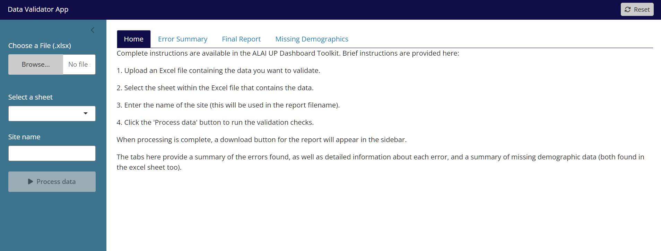
- Viewing the Data Validator Report
There are two ways to look at the Data Validator Report.
- Option 1: Clinics can view the Data Validator Report within the Data Validator
- Option 2: Clinics can download the Data Validator Report as an Excel file
We recommend downloading the Data Validator Report as an Excel file so that your clinic can take notes on data points to investigate further, and document any changes that were made to the data file or source data.
Note: If your clinic takes notes, adds formatting, or otherwise amends the Data Validator Report file, please take care to rename this file (e.g., appending “_Notes_Date” to the end of the file name) so that if you run the Data Validator again, your clinic’s amended version is not overwritten by a newly generated report.
- Reviewing your Data
The Data Validator Report contains a tab called “Error Summary” that gives a high-level overview of how many errors occurred within the different categories of errors. It is intended to give an overview only.
The remaining two tabs, “Final Report” and “Missing Demographics”, contain the detailed findings. We recommend downloading and opening the Data Validator Report and opening your clinic’s data file at the same time, so that you can make updates and corrections easily as needed.
The Final Report tab has 7 columns: UID, description, column1, value1, column2, value2, and date_difference.
- The Description gives you a brief explanation of potential errors in the data.
- Column1 tells you specifically which variable is being flagged. If there is a relevant value for that variable (e.g., a viral load), it will be inputted into Value1. If the potential error involved a relationship between 2 variables (e.g., two injection dates are entered out of chronological order), Column2 and Value2 will show this.
Below are some examples of the logical and missingness errors the Data Validator Report will flag.

Table 2. Example Data Validator Report (Final Report Tab)
uid | description | column1 | value1 | column2 | value2 | date_difference
1 | invalid not eligible reason, should be 1, 2, 3, 4, 5, 6, 7, 8, 9, 10, or 20 | icab_rpv_not_elig_1_reason | 13
2 | iCAB/RPV interval is missing. Please enter missing iCAB/RPV interval. If no shot was delivered, then delete shot date. | icab_rpv_shot2_interval
2 | iCAB/RPV injection is late. Check to ensure injection is actually late. Check to ensure that the correct interval is listed (bi-monthly vs. monthly injection). Check to ensure previous shot data is not missing. | icab_rpv_shot5_date | 2024-06-13 | icab_rpv_shot6_date | 2024-8-12 | 60
3 | Warning: iCAB/RPV shot date is in future. Check to ensure that the shot date is correct. | icab_rpv_shot3_date | 2035-01-01
4 | Warning: iCAB/RPV prescription date is before January 22, 2021 (before iCAB/RPV was FDA approved) or after today’s date. Check to ensure that the prescription date is correct. | icab_rpv_rx_date | 2020-12-01

- UID 1: In the first row, the description shows that UID 1 has an invalid reason for not being eligible for iCAB/RPV. Column1 shows that the variable in question is “icab_rpv_not_elig_1_reason”, and Value1 shows that the value entered was “13”. A clinic could then go back to the data file (or original data source) to update this value appropriately.
- UID 2: In the second row, the description shows that UID 2 is missing an “interval” value. Column1 shows that the variable in question is “icab_rpv_shot2_interval”. A clinic could then go back to the data file (or original data source) to input this data. If the value is truly unknown, a clinic can enter UNK to flag to themselves in the future that this value is truly unknown; however this missing value will still be flagged in future validations.
- UID 2: In the third row, the description says that UID 2 has a late injection (note that the same UID can have multiple rows in this table as a row is created for each flag). Column1 and Column2 show that the variables in question are “icab_rpv_shot5_date” and “icab_rpv_shot6_date”. Value1 and Value2 show that iCAB/RPV shot 5 was delivered on 6/13/24, and shot 6 was on 8/12/24, about 2 months later. If after investigating in the source data that these dates are accurate and no data are missing (e.g., missing injection date), then they can be left as is, however this late injection will still be flagged in future validations (and clinics should ignore this flag in the future). However, clinics may want to check if (a) there is an injection in between those two injections that should be entered or (b) the “interval” value for shot 5 is incorrect (e.g, coded as monthly when it should be bi-monthly).
- UID 3: In the fourth row, the description offers a warning that UID 3 has an iCAB/RPV injection date that that is in the future. Column1 shows that the variable in question is “icab_rpv_shot3_date”, and Value1 shows a year of “2035” which is not possible. A clinic should then go back to the data file (or original data source) to update the date.
- UID 4: In the fifth row, the description shows that the prescription date for iCAB/RPV may be too early. Column1 shows that the variable in question is “icab_rpv_rx_date”, and value1 shows that the year of prescription was 2020. If this date is correct, if it is can be left as is. However, because this is before iCAB/RPV FDA was approved, this prescription date will still be flagged in future validations (and clinics should ignore this flag in the future).

Clinics may receive other warnings that follow a similar structure. As you can see, some of these warnings can be safely ignored if the data are accurate. However, all warnings should be verified to ensure accuracy.
The Missing Demographics tab is informational, to quantify how often values are missing for important variables. Missing values may be OK if they are genuinely missing, clinics should investigate missingness if the number of variables missing is higher than expected. To identify missing values in the Data Template, use the filter button filter for rows that are missing particular values.

Table 3. Example Data Validator Report (Missing Demographics Tab)
column | n_missing | total_count
vital_status_alive | 1000 | 1000
zip_code | 0 | 1000
birth_date | 0 | 1000
ethnicity_hispanic | 0 | 1000
race_ai_an | 0 | 1000
race_asian | 0 | 1000
race_black | 0 | 1000
race_nh_pi | 0 | 1000
race_white | 0 | 1000
sex | 0 | 1000
risk_msm | 0 | 1000
risk_idu | 0 | 1000
risk_heterosex | 0 | 1000
health_care_coverage | 17 | 1000
housing_status | 50 | 1000
employment_status | 45 | 1000
poverty_level | 200 | 1000
immigration_status_undoc | 119 | 1000
language | 7 | 1000
incarceration_history | 61 | 1000
active_2021 | 0 | 1000
active_2022 | 0 | 1000
active_2023 | 0 | 1000
active_2024 | 0 | 1000
active_2025 | 0 | 1000
active_2026 | 0 | 1000
active_2027 | 1000 | 1000
active_2028 | 1000 | 1000
active_2029 | 1000 | 1000
active_2030 | 1000 | 1000

- Data Validator Frequently Asked Questions
- The program will not run for me or appears to crash.
  - There are many possible reasons the data validator does not run as expected. One common reason is having missing or misspelled column names. Make sure to carefully follow the Data Preparation Guide and Data Dictionary. instructions in preparing your data. If you continue to encounter issues, please contact us at alai_up@cumc.columbia.edu
- Why are there so many errors in my Data Validator Report?
  - There are many reasons for this. If the same coding mistake was made throughout the data set, then that same error will repeat in each row, generating many “errors”. Another common type of “error” is early or late injections. Clinics should investigate these errors the first time they are flagged, and keep track which “errors” are true errors that need to be addressed. But if the injection dates and intervals are determined to be complete and correct, future flagging of these “errors” can be ignored.
- Do I have to fix every error?
  - No. Strictly speaking, the Dashboard will likely still run even with errors in your data set. However, errors may result in data being ignored in calculations or illogical results being displayed on the Dashboard. Consult Data Preparation Guide and Data Dictionary to understand how variables and response options are being used in the Dashboard and then use your best judgement in evaluating the errors and determining whether changes need to be made.

Data Validator (link)
The Data Validator tool is a web-based tool available at: https://alai-up.github.io/alai_up_data_validator/
The Data Validator is a point-and-click program that does not require any programming knowledge or data-sharing to run. The Data Validator program code is written in R software using the shiny package. To make the tool more user friendly, ALAI UP has designed this program to run through standard internet browsers (e.g., Google Chrome, Microsoft Edge, Safari) using the shinylive package. Users interested in running the tool locally through RStudio or other programs may access the code at https://github.com/alai-up/alai_up_data_validator. Instructions for doing so are outside of the scope of this guide.
Although the Data Validator program is accessed and run through internet browsers, clinic data are not saved, shared, or uploaded online at any time. Throughout the whole process of using the tool, clinic data stay local to the computer running these programs.

STEP 4: Upload cleaned clinic data onto Dashboard to track LAI ART implementation process, identify gaps in care, and guide quality improvement

ALAI UP Dashboard

Dashboard User Guide
Overview and Purpose
The ALAI UP Dashboard is a comprehensive, web-based platform designed to help clinics monitor their long-acting injectable HIV treatment (LAI ART) programs. The Dashboard Toolkit can be used by clinic leadership, LAI ART program leads, data management and quality teams, and other stakeholders to:
- Track progress toward their implementation goals for their LAI ART program
- Identify gaps in LAI ART care delivery across different social determinants of health
- Guide efforts to address gaps and improve the quality of services for all clients
The Dashboard has functions to:
- Visualize process and clinical outcome data related to a clinic’s LAI ART program
- Support downloading of visualizations for use in internal and external presentations
- Disaggregate and compare data by different social determinants of health
- Filter data to specific time periods to examine changes over time and impact of programmatic changes
- Filter or aggregate data across sites if clinics are part of a larger health care system
Currently the Dashboard is optimized to track injectable cabotegravir/rilpivirine (iCAB/RPV) implementation specifically. Future iterations of the Dashboard may include other LAI ART modalities.
Quick Start
- To use the Dashboard, prepare your data in accordance with the Data Preparation Guide and Data Dictionary. Refer to the Guide to Monitoring Long-Acting Injectable Antiretroviral Therapy (LAI ART) Delivery for additional information.
- Check your data using the Data Validator. Additional instructions are in the Data Validator User Guide
- Access the ALAI UP Dashboard at https://dashboard.alai-up.org/.
- Select your file, process your data, and begin exploring the Dashboard.
Step 1: Preparing your Data
Refer to the Data Preparation Guide and Data Dictionary for full instructions on how to prepare your client-level data for use in the Dashboard.
Next, use the Data Validator tool to help check for mis-specified, missing, or inconsistent data. Refer to the Data Validator User Guide for more details.

Step 2: Accessing the Dashboard
There are two options for accessing the Dashboard.
Option 1: Through an Internet Browser (Recommended)
The recommended way to access the Dashboard is online at https://dashboard.alai-up.org/ . Please note that it may take a minute or two for the Dashboard to load when you first go to the page.
Option 2: Download Dashboard Program and Run using R and RStudio
For users familiar with R software, complete code to run the Dashboard as a local R Shiny app is available here: https://github.com/alai-up/alai_up_local_dashboard. Complete instructions for doing so are beyond the scope of this user guide.
You can download R and RStudio from this link: https://posit.co/download/rstudio-desktop/
Open the R Project in RStudio, open the app/ui.R file, and run the Shiny app. You may need to install the necessary packages.

Step 3: Using the Dashboard

Processing Data (Home page)
- The first step in using the Dashboard is to choose a data file and process the data (i.e., apply the code). Use the “Browse” button to select the Excel file containing your final prepared data on your computer. A file explorer will open for you to select the file.
- Choose the ‘sheet’ of the excel file containing your data. If there is only one sheet it will automatically be selected.
- Type a name for your site/organization. This will appear on the titles of figures throughout the Dashboard and as file names.
- Click “Process Data”. It may take a few moments to process your data. A check mark will appear on the button with the words “Data is ready” indicating that the data processing has completed. You may now proceed to the other pages of the Dashboard.
- If you receive an error message at this step, it is likely because critical column names have been misspelled, are missing, or are duplicated. Check to make sure that the column names follow the guidance in the Data Preparation Guide and Data Dictionary. Another source of the error may be that clinic-specific variables that you included in the data set have the same key words (e.g., HIV, VL, iCAB_RPV) as essential variables that the Dashboard programming searches for. To address the error message, you may need to remove added variables that are not explicitly asked for in the Data Dictionary and Data Template.
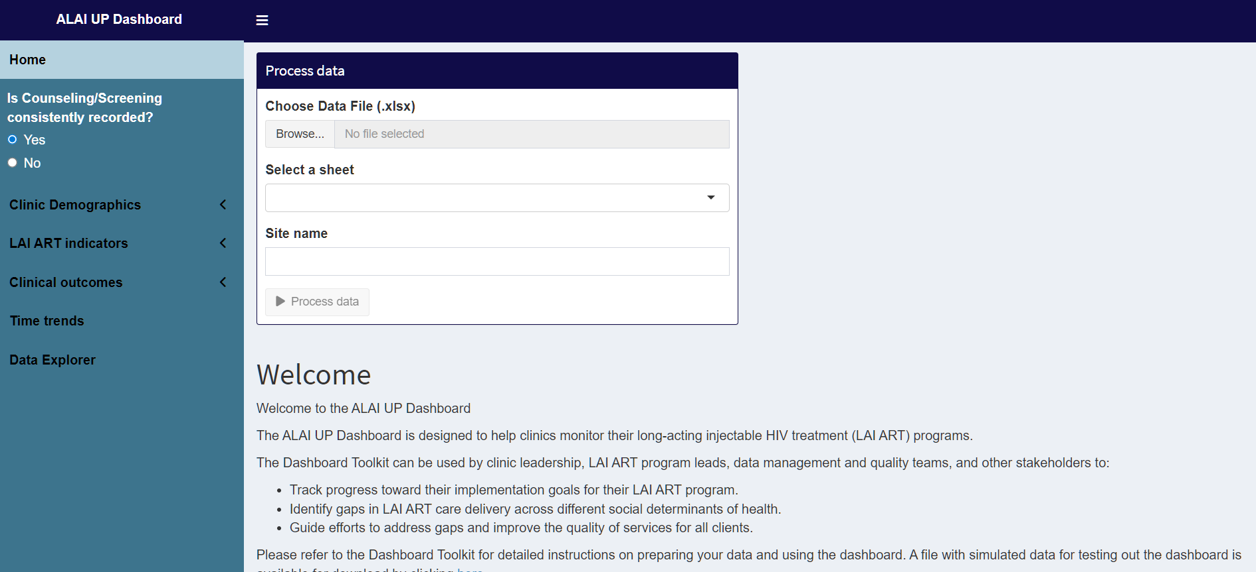

Navigating the Dashboard
The Dashboard consists of several pages that can be accessed via the Navigation Panel on the left. Users can also adjust Dashboard preferences to fit their clinic’s current workflow/definition.

Select Dashboard Preferences
After the data have been processed, users have the option to select their preference in the Navigation Panel for how the following data elements are displayed in the Dashboard. Below is a list of preferences that users can select.
- Inclusion of counseling/screening data in the Gap Analysis: If the counseling and screening history for all clients is consistently recorded at your clinic and data are available for inclusion in the Dashboard, select “Yes” for the question “Is Counseling/Screening consistently recorded?”. Otherwise, select “No”. Selecting “Yes” includes “Assessed for LAI ART” as the first step in the Gap Analysis and provides access to additional pages in the Dashboard related to counseling and screening sub-indicators. Selecting “No” removes “Assessed for LAI ART” from the Gap Analysis, makes “Prescribed LAI ART” the first step of the Gap Analysis, and hides pages related to counseling and screening for LAI ART from the Dashboard.
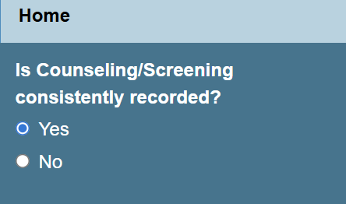
- Viewing data from multiple sites or a single site: If your data set includes data for multiple sites (indicated in the ‘site’ column of your data), a dropdown box will appear to allow users to choose to view data for all sites or a single site at a time. If no ‘site’ names were provided or there is only one site, this dropdown will not appear.
- Filtering the Dashboard to current or past clients: The Filter Clients by Active Year checkbox will reveal additional filters that will allow the user to select which client data to show (e.g., clients active during specific years). Note that activating these filters requires re-processing the data, which may take a moment.
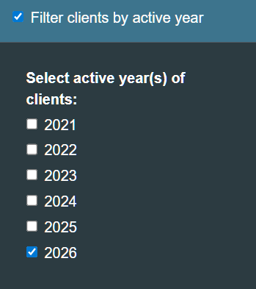
  - Select Active Year of Clients. By default, the Dashboard shows all clients in the data set. However, a user may want to filter to only data from current clients (because these are clients that the clinic can intervene on now) or may want to view historical data to compare clients who were served at the clinic during a past year to clients who are currently active at the clinic this year. This option is only available to clinics that inputted data into the “active year” columns of the data template during the data preparation step.
To filter data to only clients who are currently active at the clinic, select the current year (e.g., Active Year of Patient = 2026).
If it is near the end or beginning of the year, a user may want to filter to clients who are active in the current year or were active in the previous year (e.g., Active Year of Patient = 2025 or 2026) by selecting multiple years.
Finally, to compare data from year to year, users can filter the data to include only clients active in the current year (e.g., Active Year of Patient = 2026), download the figures/tables, and then filter the data to a historical comparison year and again download figures/tables (e.g., Active Year of Patient = 2023).

Downloading Data and Visualizations from Dashboard
At the bottom of the Navigation Pane, there is a “Download Results” button that allows you to download summary data from the main Dashboard pages and the on-time injections page. This can be helpful for saving a snapshot of your data for future reference and for also making your own graphs/visualizations in your preferred style.
Additionally, each individual plot in the Dashboard has the option to download the image of the plot or the underlying summary data for the plot.
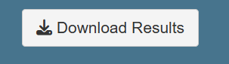

Step 4: Exploring the Dashboard Pages
In the following section, we will highlight key Dashboard pages, their features, and how users can use the data visualized on these pages to monitor aspects of their LAI ART program.

Dashboard Home Page
The Home Page contains fields to select your data file and process your data. There are also brief instructions and acknowledgements.

Clinic Demographics (Overall)
This page shows overall clinic demographics and client characteristics for all clients with HIV served at your clinic, regardless of LAI ART use. Use the “Jump to Section” to see plots showing the distribution of the population by sex, race, ethnicity, age, HIV medication payor, and key populations. There is also a heat map that visualizes clients served at your clinic by ZIP code.
For the key populations plot, there is a dropdown to select which key population/social determinant of health you are interested in looking at. If data are missing from a particular column, those rows will appear as “unknown”.
To populate the ZIP code heat map, click “create map”; it may take a moment to process. Darker colors indicate a higher concentration of clients, while lighter colors indicate a lower concentration of clients. Please use caution when sharing this map, as small cell sizes may risk client confidentiality.

Clinic Demographics (by LAI ART use)
This page shows overall clinic demographics and client characteristics, for all clients with HIV served at your clinic, stratified by LAI ART use. Use the “Jump to Section” to see plots showing the distribution of those ever on LAI ART and those never on LAI ART by sex, race, ethnicity, age, HIV medication payor, and key populations. There is also a heat map that visualizes clients served at your clinic who were ever on LAI ART by ZIP code.
Interpreting these plots.
These plots show the distribution of a given variable (e.g. age) within a population of clients ever on LAI ART and a population of clients never on LAI ART. For example, in the plot below, among clients ever on LAI ART, 29% are age 25-34 (21 out of 73 clients ever on LAI ART), while among clients never on LAI ART, 23% are age 25-34 (209 out of 927 clients never on LAI ART).
To compare whether clients who were ever on LAI ART differ from clients who were never on LAI ART for a particular variable, users can compare the dark blue bars (ever on LAI ART) for a variable category (e.g., age 25-34) to the light blue bars (never on LAI ART) for the same variable category. 29% of people ever on LAI ART are age 25-34 compared to 23% of people never on LAI ART; this difference represents a care gap where people 25-34 are overrepresented among clients ever on LAI ART, relative to their representativeness at the clinic (red arrows).
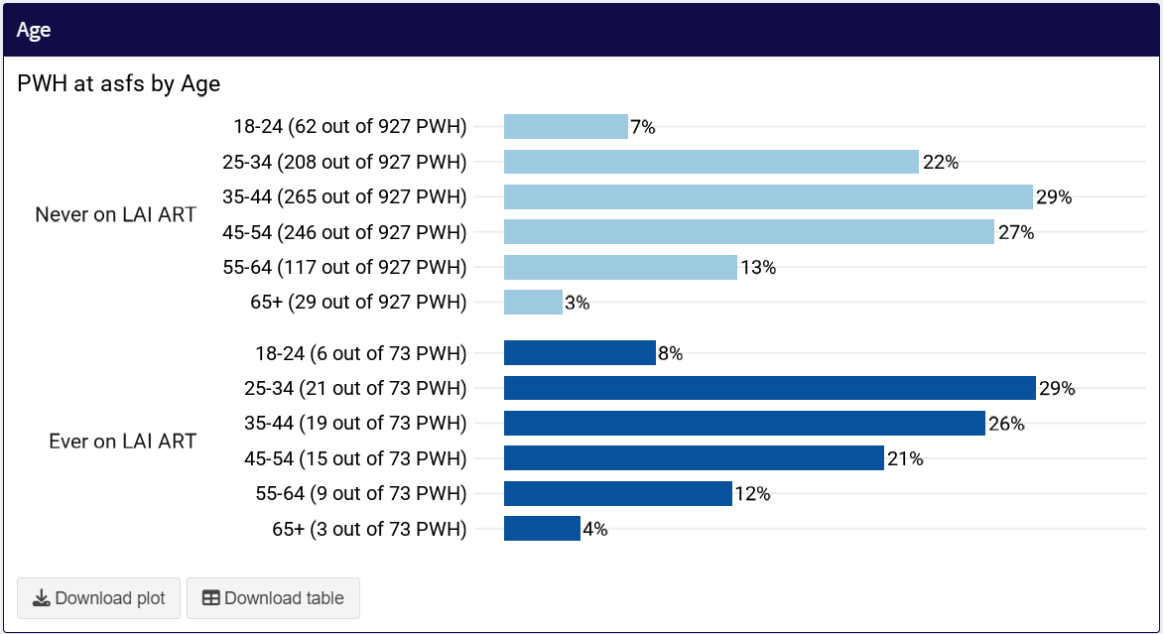
At the same time, 12% of clients ever on LAI ART are age 55-64 and 13% of clients never on LAI ART are age 55-64; these distributions are nearly equal, suggesting the absence of a care gap (blue arrows).
Finally, 21% of clients ever on LAI ART are age 45-54, while 27% of clients never on LAI ART are age 45-54. This demonstrates a care gap where clients age 45-54 are under-represented among clients on LAI ART at the clinic, relative to their representativeness at the clinic (purple arrows).
On the ZIP code map, darker colors indicate a higher concentration of clients ever on LAI ART, while lighter colors indicate a lower concentration of clients ever on LAI ART. Please use caution when sharing this map, as small cell sizes may risk client confidentiality.

LAI ART Indicators – Overview
This page contains two plots, giving an overview of the LAI ART indicators.

LAI ART Care Gap Analysis
This plot shows the proportion of clients at a clinic who have been Assessed for LAI ART, are Interested and Eligible for LAI ART, have been Prescribed LAI ART, Initiated LAI ART, and are Sustained on LAI ART. This gives an overview of where the “gaps” in getting clients on LAI ART are occurring. Note that Assessed and Interested and Eligible can be hidden if counseling and screening are not consistently recorded, per the Dashboard preferences in the Navigation Panel.
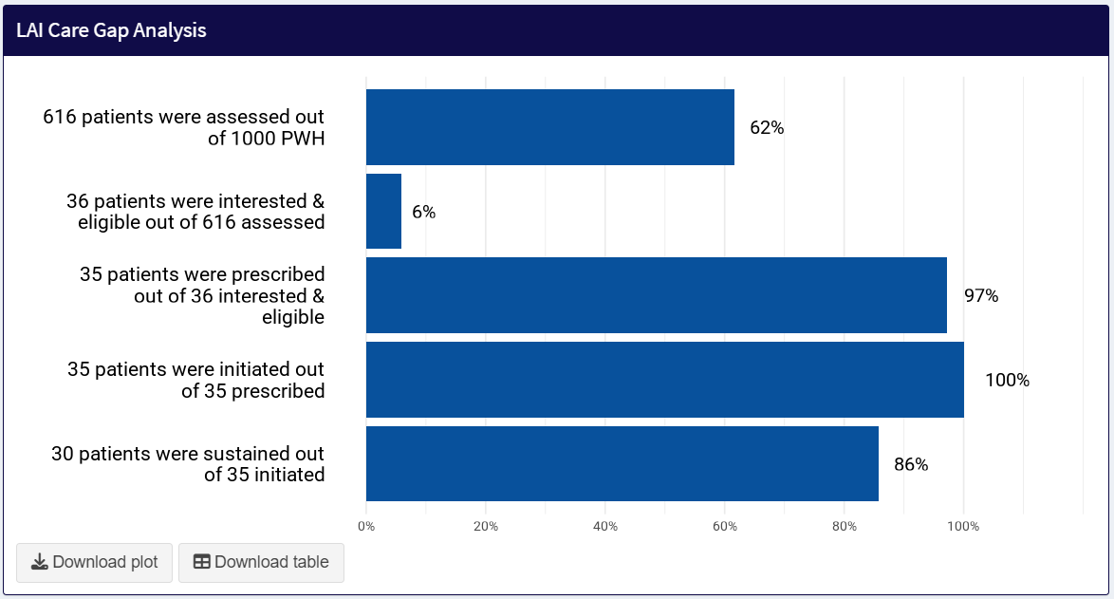

Core Indicator 2: Interested and Eligible
This page shows the distribution of counseling and screening outcomes among those assessed. The "Percent" buttons allow you to change how the percentages are calculated: select "table" for using the number assessed as the denominator, "row" for using the row total, and "column" for using the column total. For example, to see the percent eligible among those interested, using the row percent. The blue highlighted cell shows the number interested and eligible, as in the LAI ART care gap analysis. This page is hidden if counseling and screening are not consistently recorded.
If your percent interested & eligible among those assessed in the LAI ART Care Gap is very low, this chart can help you identify if the gap is driven by lack of interest or ‘maybe interested’ clients, or whether clients are interested but not clinically eligible.
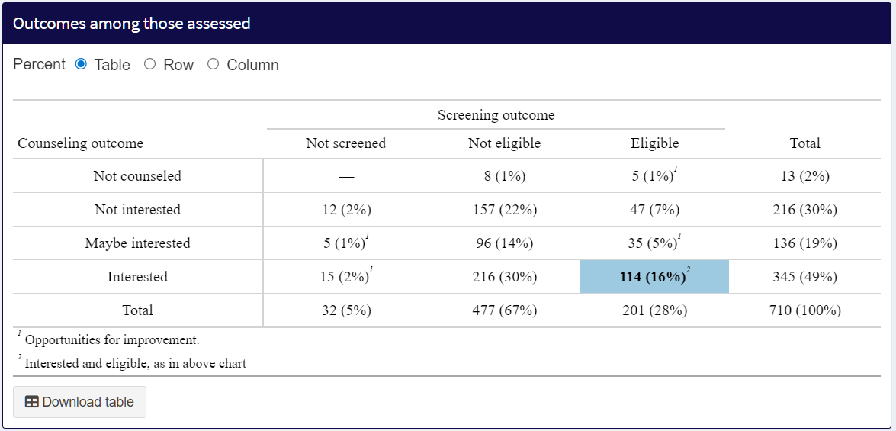

LAI ART Indicators – Detailed Pages
The detailed indicators pages share a similar structure and disaggregate the different LAI Art indicators by demographics and social determinants of health. There are also plots of events over time. Where relevant, there are also additional plots for reasons (on the Interested, Eligible, Accessible, and Sustained pages). Detailed indicator descriptions may be found in the Guide to Monitoring Long-Acting Injectable Antiretroviral Therapy Delivery.
The following plots are common to the 8 core indicator/sub-indicator pages and share similar structure: overall, by sex, race, ethnicity, age, HIV medication payor, and key populations.

Core Indicator 1: Percent Assessed for LAI ART
This page shows the number and percent of clients with HIV at your clinic who were assessed. "Assessed" is a combined indicator defined as the proportion of clients counseled about LAI ART or screened for LAI ART clinical eligibility out of clients with HIV served at the clinic within a given time period.
There are 9 plots: Overall, by sex, race, ethnicity, age, HIV medication payor, and key populations, assessed over time by person, and assessed over time by encounter.
The Overall plot simply shows the percent assessed out of the total clients at the clinic.
The plots by sex, race, ethnicity, age, HIV medication payor, and key populations have identical structure. They show the percent assessed out of the total number of clients in each demographic/social determinant group. This enables quick and easy comparisons to understand if there are any differences in assessed by different variables. The dashed line indicates the average, the same value in the Overall plot. Bars above or below the average indicate differences occurring within that variable.
Bars appear gray when the denominator is <10, to indicate the added uncertainty.
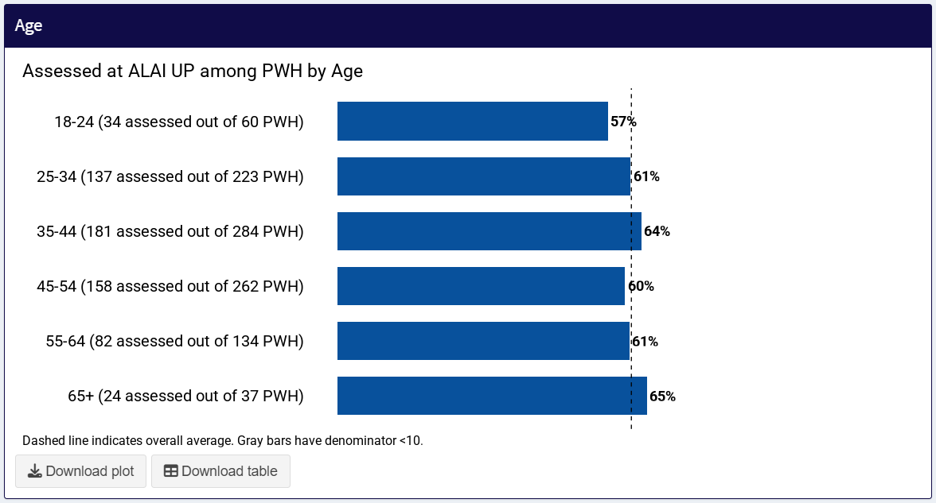
Assessed over time by person shows the number of people assessed by month, based on their most recent assessment date.
- Each person can show up at most 1 time
- The date reflects their most recent assessment. If a person was assessed multiple times, only the most recent assessment is reflected.
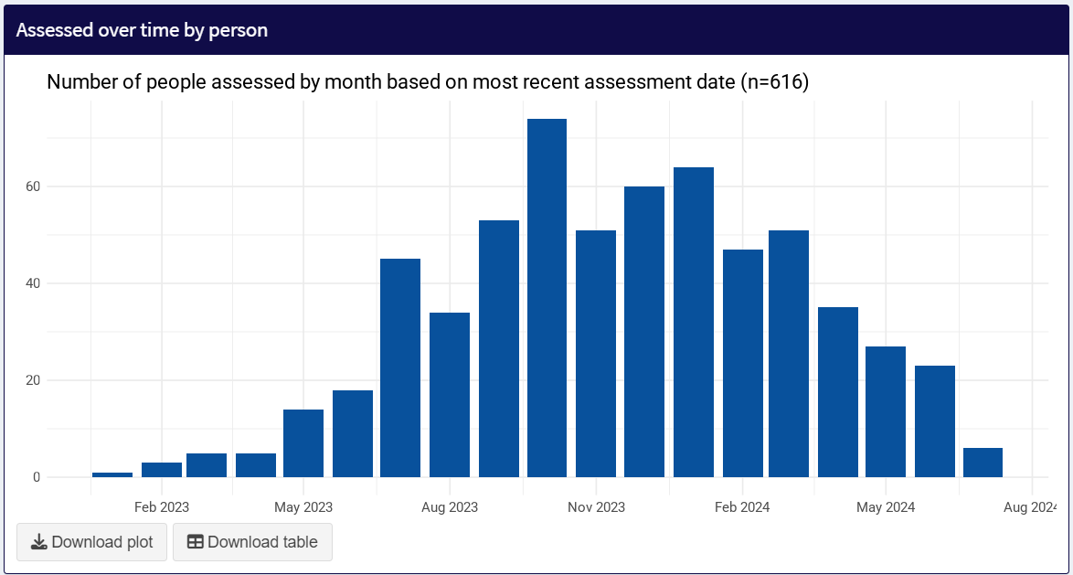
Assessed over time by encounter shows the number of assessments occurring each month. This includes all unique dates when a person was assessed.
- Each person can show up multiple times
- The date reflects the date the assessment occurred
- If counseling and screening were on the same date, they will count as 1 encounter. If they were on different dates, they will count as multiple encounters.
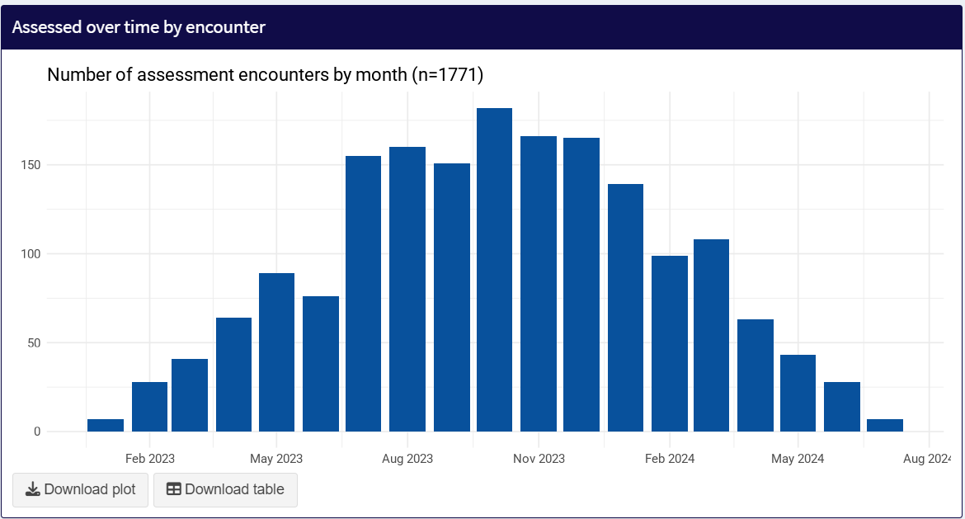

Sub-Indicator 1a: Percent Counseled about LAI ART
This page shows the number and percent of clients with HIV at your clinic who were counseled about LAI ART.
The Overall plot shows the percent counseled out of the total clients at the clinic.
The plots by sex, race, ethnicity, age, HIV medication payor, and key populations show the percent counseled out of the total number of clients in each demographic/social determinant group.
Counseled over time by person shows the number of people counseled by month, based on their most recent counseling date.
Counseled over time by encounter shows the number of counseling events occurring each month. This includes all unique dates when a person was counseled.

Sub-Indicator 2a: Percent Interested in LAI ART
This page shows the number and percent of clients with HIV at your clinic who were interested in LAI ART after being counseled.
The Overall plot shows the percent interested out of the total clients ever counseled.
The plots by sex, race, ethnicity, age, HIV medication payor, and key populations show the percent interested out of the total number of clients ever counseled in each demographic/social determinant group.
Interested over time by person shows the number of people counseled by month, based on their most recent counseling date, with the color representing the number interested/maybe interested/not interested.
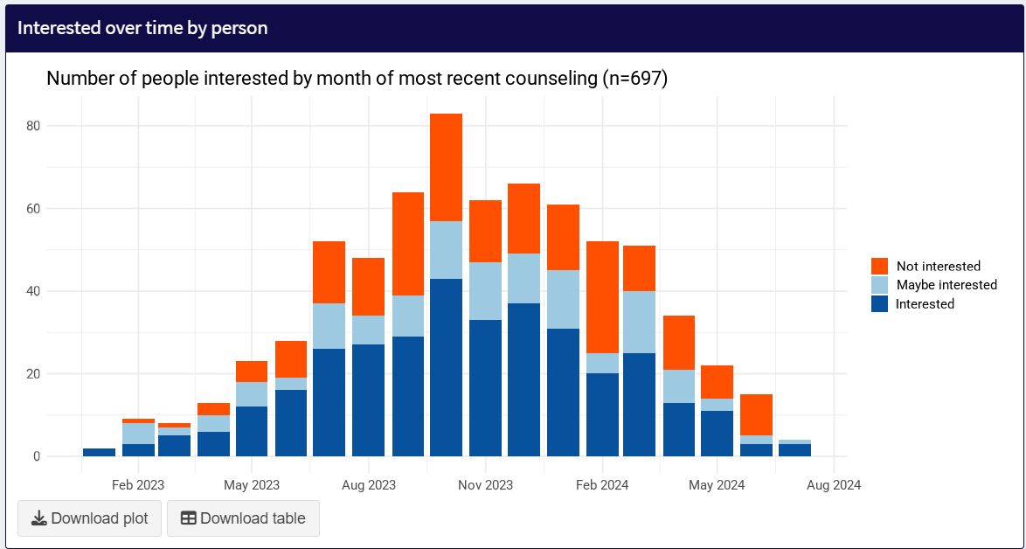
Interested over time by encounter shows the number of counseling events occurring each month. This includes all unique dates when a person was counseled. The color represents the number interested/maybe interested/not interested.
Finally, the not interested reasons plots displays the number and percent reporting each reason among those maybe interested or not interested.
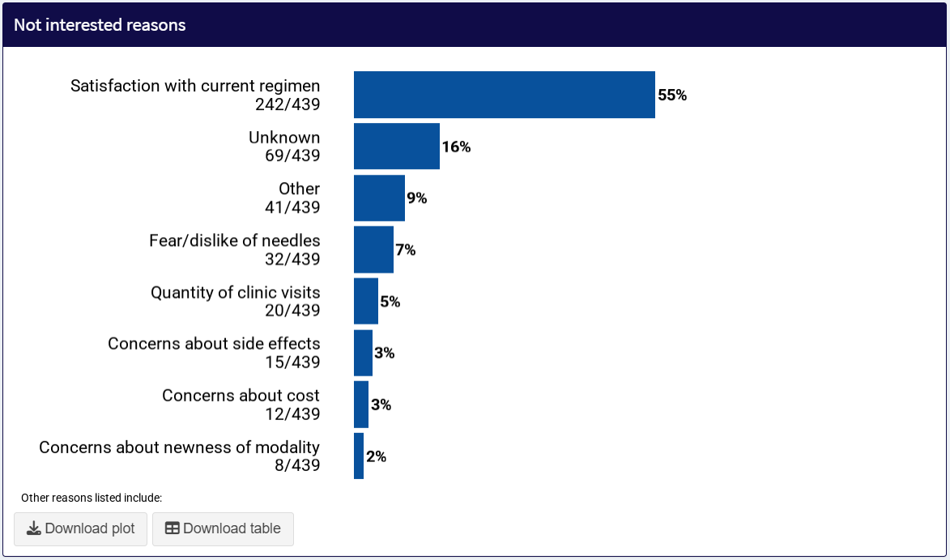

Sub-Indicator 1b: Percent Screened for LAI ART
This page shows the number and percent of clients with HIV at your clinic who were screened for eligibility for LAI ART.
The Overall plot shows the percent screened out of the total clients at the clinic.
The plots by sex, race, ethnicity, age, HIV medication payor status, and key populations show the percent screened out of the total number of clients in each demographic/social determinant group.
Screened over time by person shows the number of people screened by month, based on their most recent counseling date.
Screened over time by encounter shows the number of screening events occurring each month. This includes all unique dates when a person was screened.

Sub-Indicator 2b: Percent Eligible for LAI ART
This page shows the number and percent of clients with HIV at your clinic who were eligible for LAI ART after being screened.
The Overall plot shows the percent eligible out of the total clients ever screened.
The plots by sex, race, ethnicity, age, HIV medication payor, and key populations show the percent eligible out of the total number of clients ever screened in each demographic/social determinant group.
Eligible over time by person shows the number of people screened by month, based on their most recent screening date, with the color representing the number eligible/not eligible.
Screened over time by encounter shows the number of screening events occurring each month. This includes all unique dates when a person was screened. The color represents the number eligible/not eligible.
Finally, the not eligible reasons plot displays the number and percentage of each reason among those not eligible.

Core Indicator 3: Percent Prescribed LAI ART
This page shows the number and percent of clients with HIV at your clinic who were prescribed LAI ART.
The Overall plot shows the percent prescribed out of the total interested and eligible at the clinic. If counseling/screening is not consistently recorded, the denominator is the total number of clients at the clinic.
The plots by sex, race, ethnicity, age, HIV medication payor, and key populations show the percent prescribed out of the total number of clients interested and eligible in each demographic/social determinant group.
Prescribed over time shows the number of people prescribed by month, based on the date they were prescribed.

Sub-Indicator 3a: Percent Accessible
This page shows the number and percent of clients with HIV at your clinic who could financially access LAI ART after being prescribed.
The Overall plot shows the percent who could financially access LAI ART out of the total prescribed at the clinic.
The plots by sex, race, ethnicity, age, HIV medication payor, and key populations show the percent who could financially access LAI ART out of the total number of clients prescribed in each demographic/social determinant group.
Accessible over time shows the number of clients who could financially access LAI ART by prescription month. The height of the bar represents the number of clients prescribed, and the color represents whether LAI ART was financially accessible or not.
Finally, the not accessible reasons plot displays the number and percentage of each reason among those who could not access LAI ART.

Core Indicator 4: Percent Initiated on LAI ART
This page shows the number and percent of clients with HIV at your clinic who initiated LAI ART.
The Overall plot shows the percent initiated out of the total prescribed at the clinic.
The plots by sex, race, ethnicity, age, HIV medication payor, and key populations show the percent initiated out of the total number of clients prescribed in each demographic/social determinant group.
Initiated over time shows the number of people initiating by month, based on the date they received their first injection.

Core Indicator 5: Percent Sustained on LAI ART
This page shows the number and percent of clients with HIV at your clinic who were sustained on LAI ART.
The Overall plot shows the percent sustained out of the total initiated at the clinic.
The plots by sex, race, ethnicity, age, HIV medication payor, and key populations show the percent sustained out of the total number of clients initiated in each demographic/social determinant group.
Time spent on iCAB/RPV shows the number of days that each person has spent on iCAB/RPV in the data, to date. The color shows whether they are sustained or have discontinued. This provides a high-level overview of how long clients at your clinic have been on iCAB/RPV.
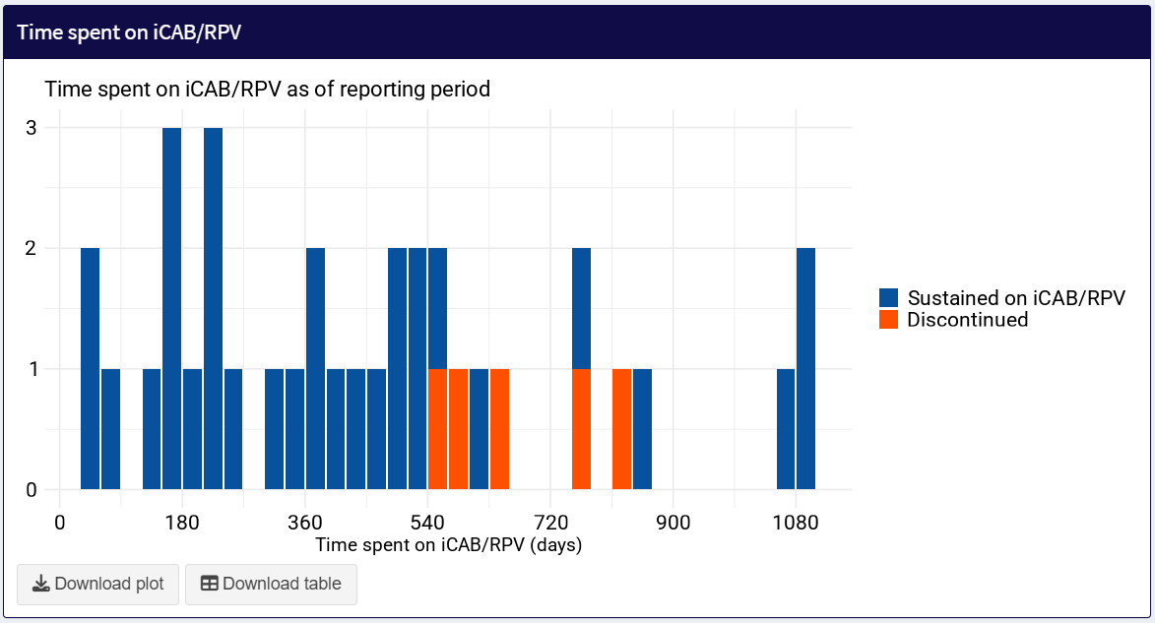

Reasons for LAI ART Discontinuation
Discontinued reasons shows the number and percent of each reason among those who discontinued LAI ART.
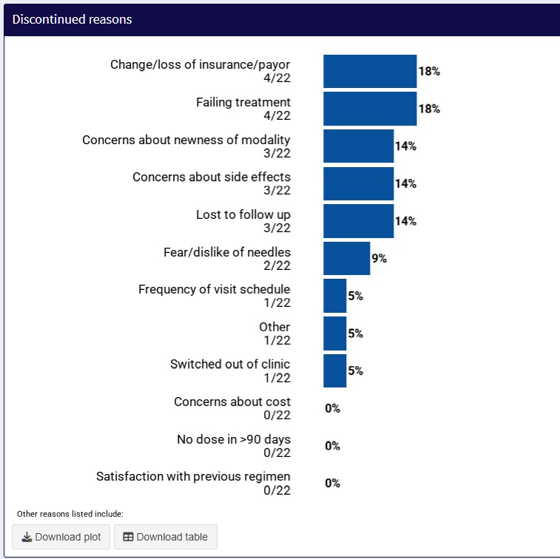

LAI ART Clinical Outcomes
This section of the Dashboard features key LAI ART clinical outcomes, including on-time injections, time to viral suppression and treatment failure, and reasons for discontinuation including lost to follow up.

Sub-Indicator 5a: Percent On-Time Injections
This page shows the numbers and percents of early, on time, and late iCAB/RPV injections out of all follow-up injections after the first injections. "Early" is defined as occurring more than seven days before the target injection date. "Late" is defined as occurring more than seven days after the target injection date. The target injection date can be toggled on the left depending on the site’s clinical practice of scheduling injections on a 4/8 week schedule or on a ½ month schedule. Depending on a clinic’s practice and what option is selected in the Dashboard, either 28 or 56 days (4 or 8 weeks), or 31 or 62 days (1 or 2 months) will be used to calculate the target interval.
For the main text string at the top of the page, note that the total number of injections, the number of individuals, and the number of follow-up/maintenance injections may not add up intuitively.
Example:
- 924 total injections were administered to 111 individuals.
- In most cases, the first injection per individual is the loading dose (cannot be late and therefore excluded from the late injection calculation)
- A clinic might assume 924 total injections – 111 first injections = 813 maintaining injections
- But the Dashboard reports that only 789 injections were maintenance injections
- There is a discrepancy of 24 injections – this is because some injections may be from clients who need to re-initiate due to a very late injection or discontinuing and starting again. Thus, these clients had more than 1 first injection. There may also be clients who initiated injections at another clinic then transferred to your clinic. Their first injection at your clinic is technically a maintenance injection, but it will not be included in the on-time injection calculation because their first injection cannot be documented as late due to missing data on previous injections completed at another clinic.
"On time injections" shows the overall percent of injections administered early, on time, and late.
"On time injections by days since prior injection" shows how early or late particular injections were, with the on time injection region shaded in gray. There is a plot for monthly injection intervals and a plot for bimonthly injection intervals. If a clinic observes many injections delivered late or injection delivered close to the end of the injection interval, they may want to consider clinic policies, for example scheduling clients at the beginning of the injection interval to provide more time for re-scheduling before the interval ends.
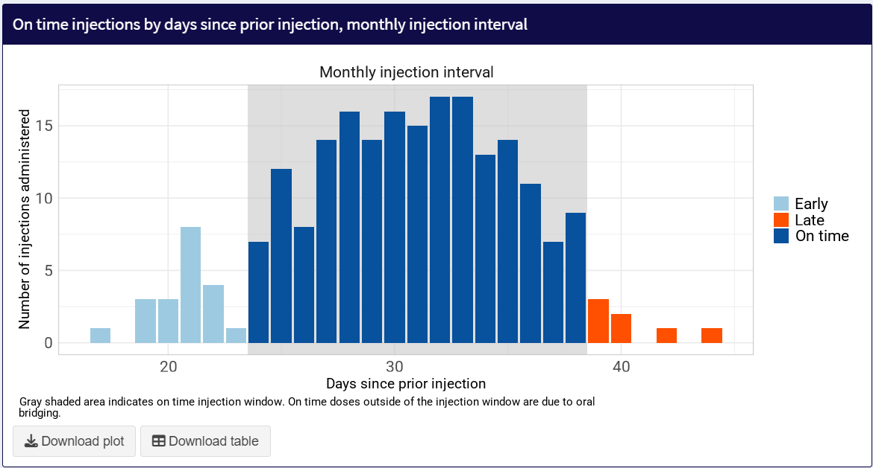

"Late injections by client" shows the distribution of late injections, by clients. This plot allows clinics to examine whether late injections are concentrated among a few clients or whether many clients are experiencing late injections once or twice.
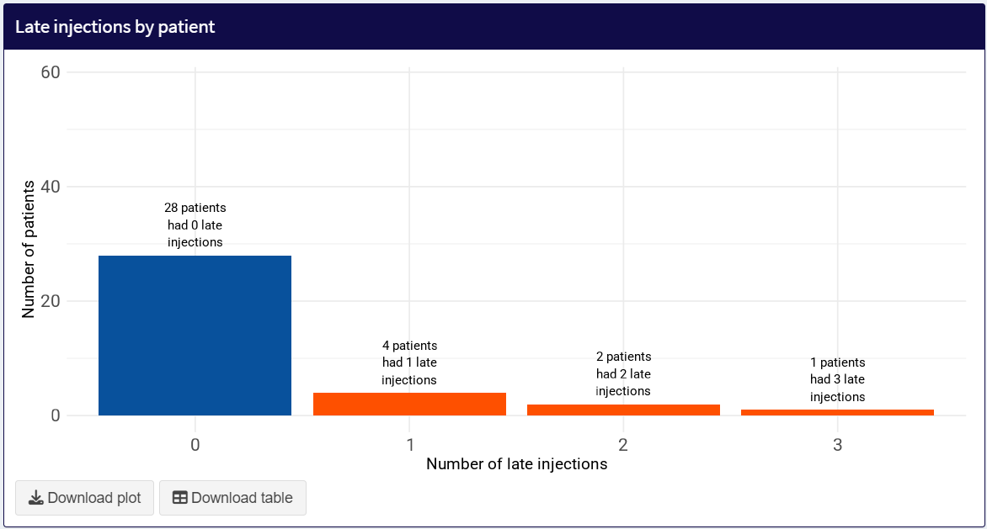

"Early injections by client" shows the distribution of early injections, by clients.

Viral Load Outcomes
This page shows viral load results among clients on iCAB/RPV. Different viral load cutoffs of interest can be selected on the left sidebar.
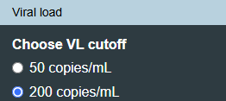
Viral Suppression: Users can define viral suppression as either a viral load <50 copies/mL or <200 copies/mL.
Elevated Viral Load: If users define viral suppression as <50 copies/mL, then elevated viral load will be defined as VL>50 copies/mL. If users define viral suppression as <200 copies/mL, then elevated viral load will be defined as VL>200 copies/mL.
Treatment failure is defined as a (1) 1 VL >1000 copies/mL, or (2) 2 consecutive VL >200 copies/mL, or (3) emergent resistance at a given time since initiating LAI ART out of all clients on LAI ART.
The viral outcomes page includes the following six plots.
- Plot 1: Among clients who start iCAB/RPV with viremia (not virally suppressed), what is the time to viral suppression?
- Plot 2: Among clients who start iCAB/RPV virally suppressed, what is the time to first elevated viral load?
- Plot 3: Among clients who start iCAB/RPV with viremia and achieve viral suppression, what is the time to first elevated viral load?
- Plot 4: Among clients who start iCAB/RPV virally suppressed, what is the time to first treatment failure?
- Plot 5: Among clients who start iCAB/RPV with viremia and achieve viral suppression, what is the time to first treatment failure?
- Plot 6: Percent of clients virally suppressed at clinic on LAI ART vs. oral ART
Plots 1-5 are calculated using the Kaplan-Meier estimator. This gives a conservative, statistical estimate of the time to the first occurrence of the event, that accounts for the uncertainty and potential bias due to clients discontinuing before they could have an outcome of interest (e.g., viral suppression, elevated viral load) and clients having variable follow-up time. Therefore, the percentages in the plots are statistical estimates, not actual raw percentages and numbers.
The number in parentheses at the bottom of each bar tells the user the number of people contributing data to each data point in the plot. Reviewing this number can give a sense of how certain or uncertain the estimate is (with more data/people creating more certainty).
Plots in the orange colorway distinguish outcomes for clients who initiate iCAB/RPV with viremia. Plots in the blue colorway distinguish outcomes for clients who initiate iCAB/RPV while virally suppressed.
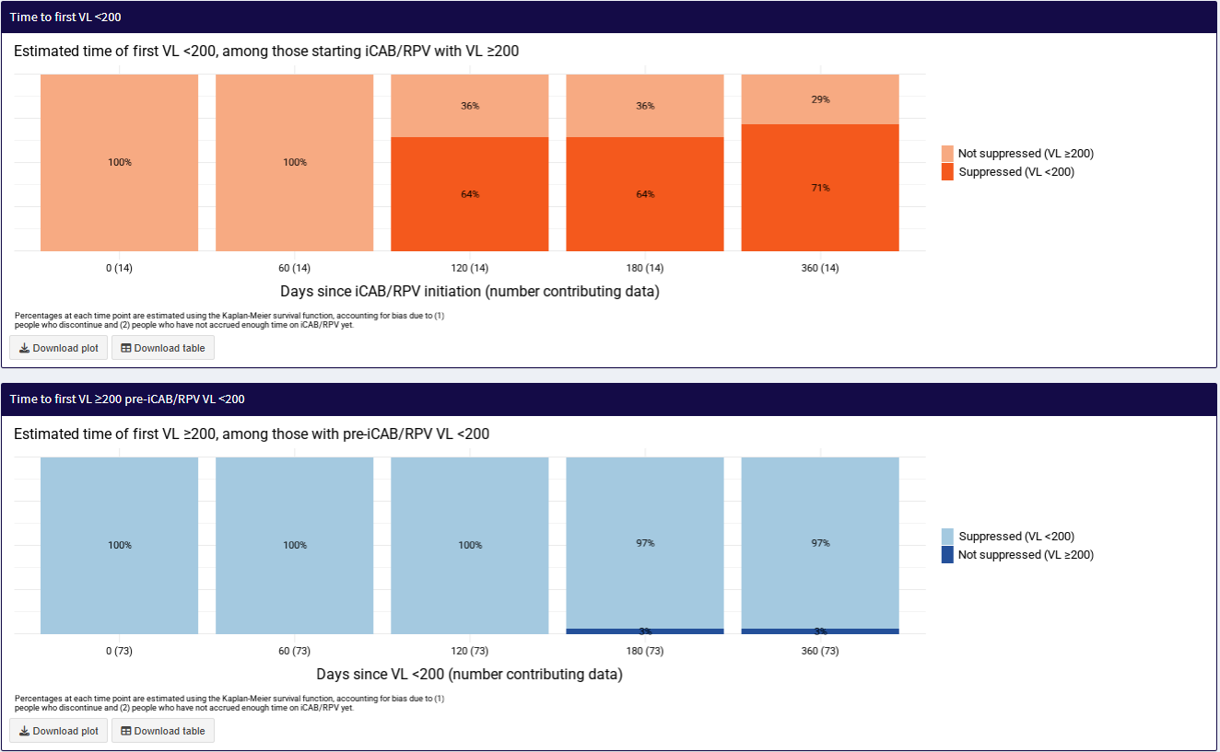

Plot 1: Among clients who start iCAB/RPV with viremia (not virally suppressed), what is the time to viral suppression?
This plot shows the percent of clients who achieve viral suppression at key time points, among clients who started iCAB/RPV with viremia. For example, in the figure below, at Day 0 (13 clients) and Day 60 (13 clients), 100% of clients are not virally suppressed (peach color). But by day 120, 85% of clients are virally suppressed (orange color). As stated above, the number in the parentheses at the bottom of each bar indicates how many clients contributed to that data point. The sooner the plot shows orange bars, the shorter the time to viral suppression for clients who initiate with viremia.
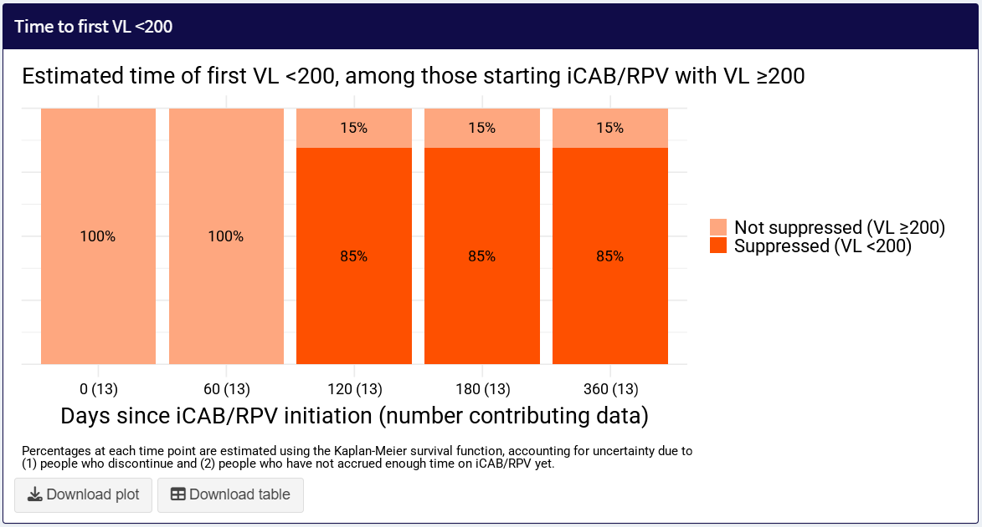

The subsequent four plots visualize events that a clinic would like to minimize. Therefore, the longer it takes for the plot to show the dark colored bars (events), the rarer the negative clinical event and the better the clinical outcomes.
Plot 2: Among clients who start iCAB/RPV virally suppressed, what is the time to first elevated viral load?
This plot shows the percent of clients who had an elevated viral load at key time points, among clients who started iCAB/RPV virally suppressed. For example, in the figure below, at Day 0 (73 clients) and Day 60 (73 clients), and Day 120 (73 clients), no clients had an elevated viral load (no dark blue bars indicating “not suppressed”). The first instance of an elevated viral load occurs at Day 180 (73 clients) where 3% of clients experienced their first elevated viral load. Stated another way, at Day 180, 97% of clients remained virally suppressed.
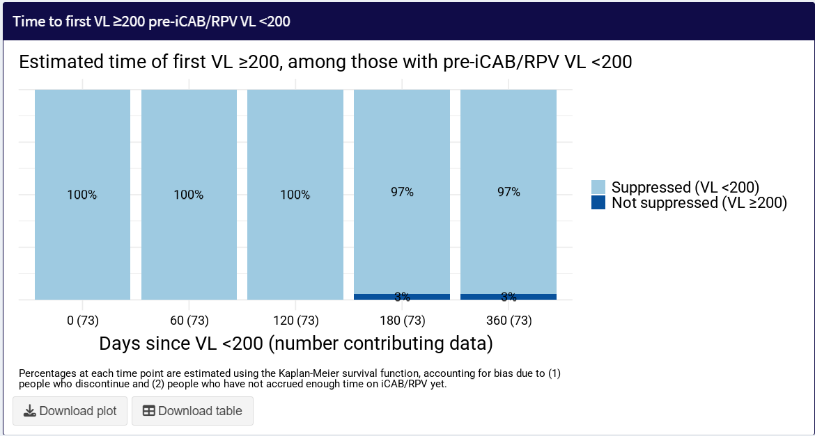

Plot 3: Among clients who start iCAB/RPV with viremia and achieve viral suppression, what is the time to first elevated viral load?
This plot shows the percent of clients who had an elevated viral load at key time points, among clients who started iCAB/RPV with viremia. For example, in the figure below, at Day 0 (14 clients) and Day 60 (14 clients), no clients had an elevated viral load (no orange bars indicating “not suppressed”). The first instance of an elevated viral load occurs at Day 120 (13 clients) where 8% of clients experienced their first elevated viral load. Stated another way, at Day 120, 92% of clients remained virally suppressed.
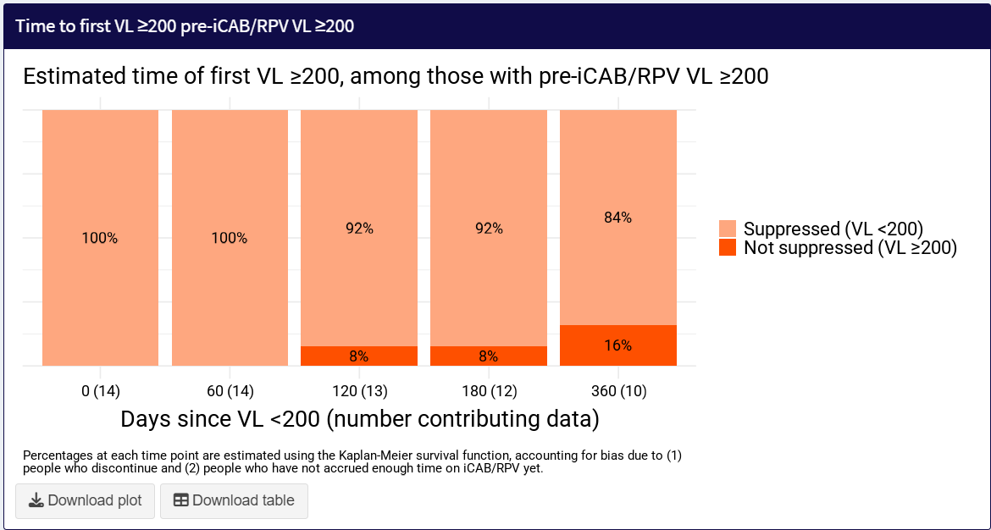

Plot 4: Among clients who start iCAB/RPV virally suppressed, what is the time to first treatment failure?
This plot shows the percent of clients who had treatment failure at key time points, among clients who started iCAB/RPV virally suppressed. For example, in the figure below, from Day 0 (73 clients) through Day 180 (73 clients), no clients failed treatment (no dark blue bars indicating “treatment failure”). The first instance of treatment failure occurred at Day 360 (73 clients) where 1% of clients experienced treatment failure. Stated another way, at Day 360, 99% of clients remained virally suppressed.
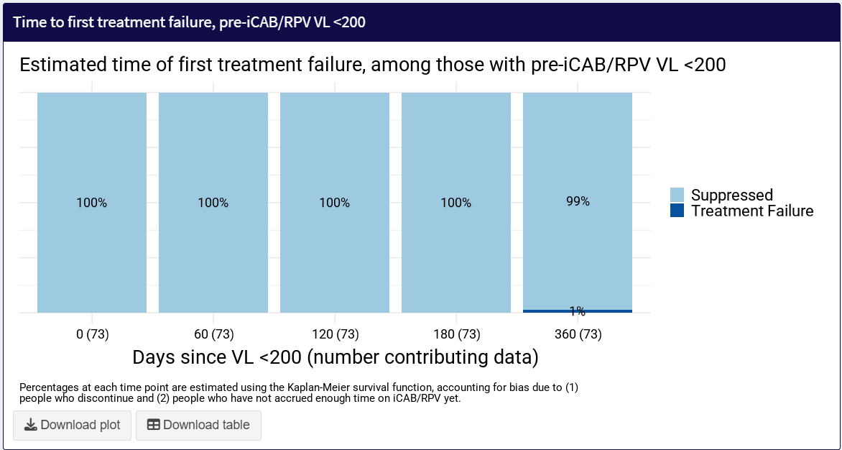

Plot 5: Among clients who start iCAB/RPV with viremia and achieve viral suppression, what is the time to first treatment failure?
This plot shows the percent of clients who had treatment failure at key time points, among clients who started iCAB/RPV with viremia and achieved viral suppression. For example, in the figure below, from Day 0 (14 clients) through Day 180 (12 clients), no clients failed treatment (no orange bars indicating “treatment failure”). The first instance of treatment failure occurred at Day 360 (10 clients) where 9% of clients experienced treatment failure. Stated another way, at Day 360, 91% of clients remained virally suppressed.
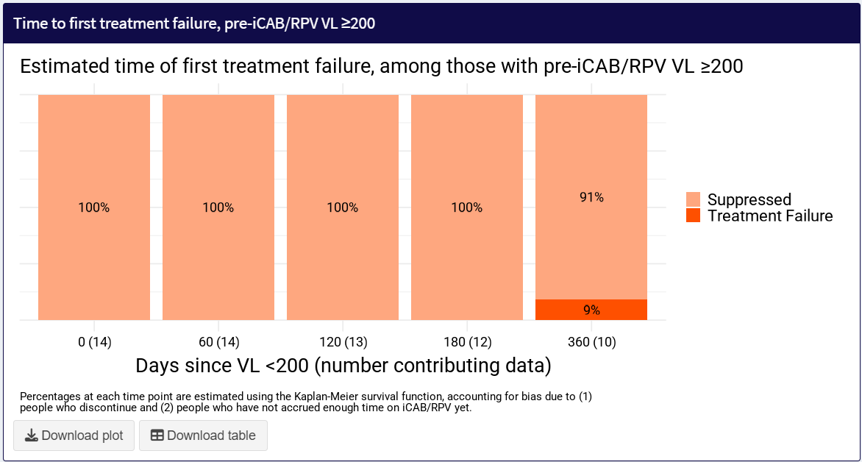

Plot 6: Clinic-Level Viral Load
This plot shows the count or percent of people with a viral load above/below a chosen threshold in a chosen time period (every 3 months, every 6 months, or every 12 months), stratified by whether or not they were ever on LAI ART during that time period.
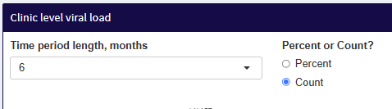
Note that, while each person can only contribute 1 most recent viral load result per time period, that does not mean that each person appears in every period. In fact, the population of people in each period can vary widely depending on who received a viral load test during that period, contributing to changes in percent or count suppressed. Therefore, this metric should be considered preliminary and interpreted with caution.
In the plot below, clinic viral loads are shown in 6 month increments and as percentages. The bar chart to the left shows the percent of clients on LAI ART whose most recent viral load during a 6 month time frame was <200 copies/mL; the bar chart in the middle shows the same except for clients on oral ART; and the bar chart to the right shows the viral load distribution for all clients on ART.
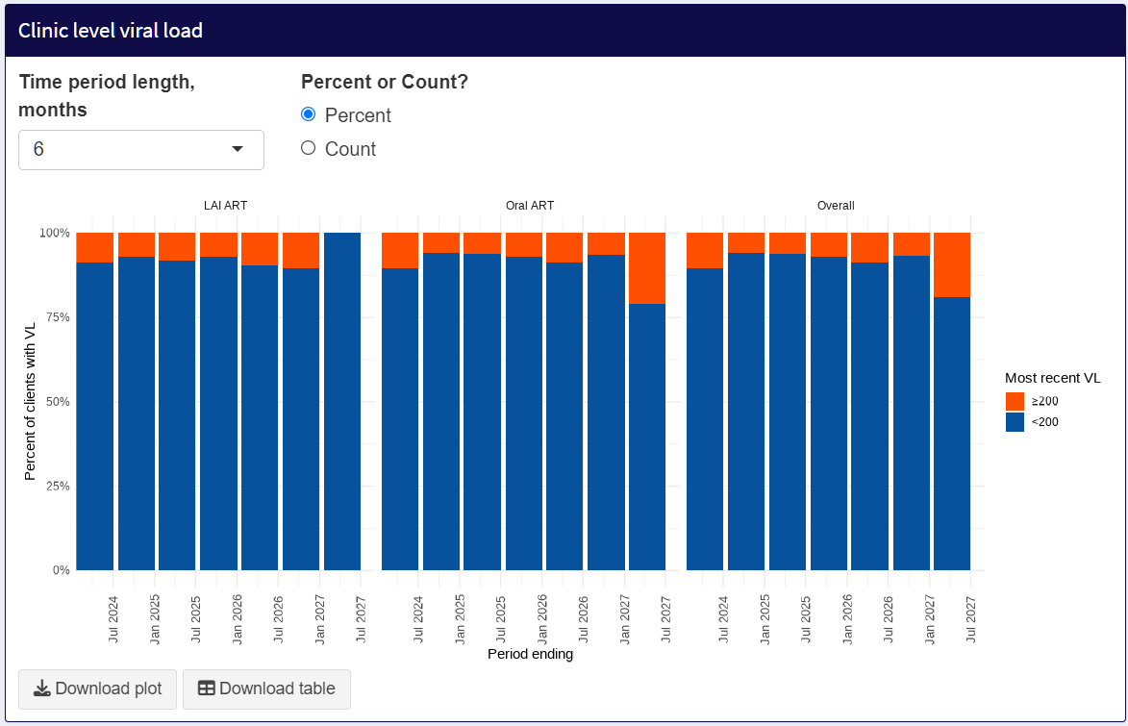
The following plot is identical except that counts of clients with VL<200 copies/mL are displayed instead of percent of clients.
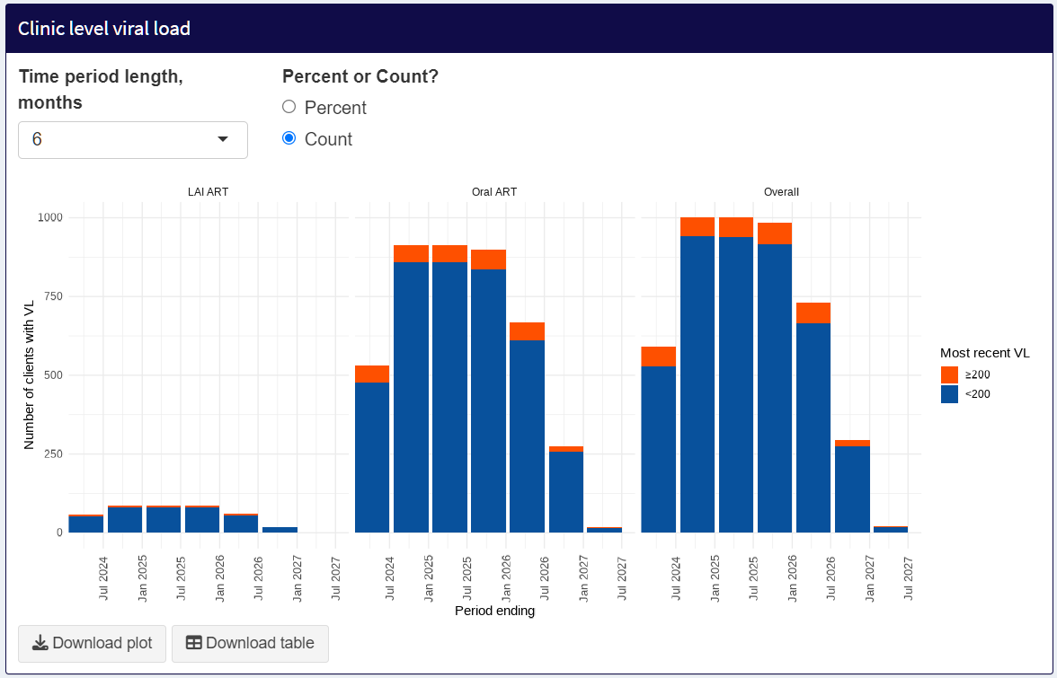

Time Trends
The Time Trends page allows users to explore changes in core and sub-indicators over time, stratified by demographics and social determinants of health. This helps users compare across subgroups to determine if care gaps have changed over time at your clinic.
Users have the option to examine time trend with two plots.
- Plot 1: Cumulative percent of a given indicator over time, stratified by group
- Plot 2: Discrete percent of a given indicator over time, stratified by group
The cumulative plot helps users identify gaps, or the closing of gaps, over time, by group. The discrete plot helps users identify if efforts to close gaps are having an impact – for example, if a gap in percent assessed is identified among women, the discrete plot can highlight whether increased efforts to specifically conduct outreach to women is resulting in a greater percent in women assessed at discrete time periods. The discrete plot measures change in the indicator during a specific time period.
To create the Time Trends plots, users will make the following selections:
- Indicator: Select the indicator to display in the plots (e.g., Assessed).
- Comparison variable: Select the demographic or social determinant of health category to compare/stratify by. Select the option “none” to see the time trend at your clinic without any stratification.
- Range of dates: Select the start and end of the data range you wish to examine. This will focus the plot (i.e. “zoom in”) on the date ranges of interest. Please note that the date range selection will NOT limit the data included to only those date ranges. The denominator for the time trends plots will include all clients in the data template. Users can limit which data are included in the plot by selecting “Select active year(s) of client”. For most use cases, we recommend checking the box for only the current year; this limits the data analysis to only those clients who are active clients at your clinic (whose process and health outcomes your clinic still has the ability to impact).
- Time period length: Select the discrete unit of time to aggregate data - monthly (1 month), quarterly (3 months) or biannually (6 months).
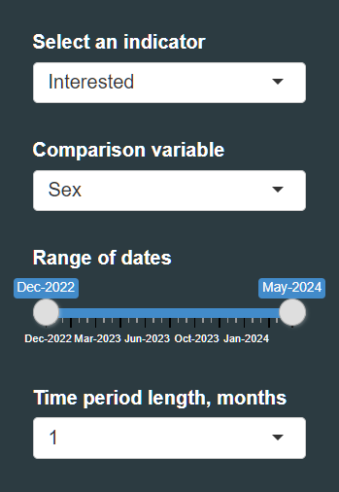
Optionally, if you want to filter the data by a second variable, the following inputs are available:
- Filter by second variable: checkbox to open the filtering options
- Filter variable: The demographic or social determinant of health variable to filter on.
- Select the groups you want to see: Select the groups you want to be included in the time trends plots. This will filter the data to only include clients belonging to the selected groups. If no groups are selected, then all clients will be included.
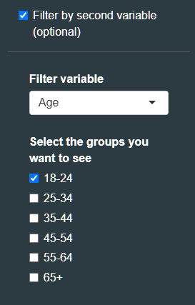
An important note about which data are included in Time Trends Plots
Across both Time Trends plots, the default denominator is all clients ever seen at your clinic (i.e., all unique clients included in the data template) in a given demographic/social determinant of health group. Users can limit which data are included in the plot by selecting “Select active year(s) of client”. For most use cases, we recommend checking the box for only the current year; this limits the data analysis to only those clients who are active clients at your clinic (whose process and health outcomes your clinic still has the ability to impact). See section Select Dashboard Preferences for more details on how to limit analyses to clients seen during specific time periods.

Plot 1: Cumulative percent of a given indicator over time, stratified by group
This plot shows the cumulative percent of a given indicator over time for each group of interest. For example, if the indicator is 'Assessed' and the stratification group is age, the plot will show the total percent ever assessed for each age group over time. The numerator for each data point is the number ever assessed during a given time period for a given age group. The denominator for each data point is the total number of people in that age group ever seen at the clinic. Note that the denominator stays constant for the whole plot.
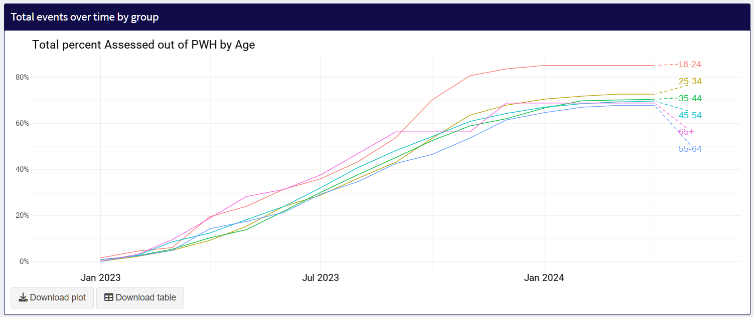

Plot 2: Monthly percent of a given indicator over time, stratified by group
This plot shows the discrete percent of a given indicator over time for each group of interest. For example, if the indicator is ‘Interested’ and the stratification group is sex, the plot will show the percent assessed for each sex group during a discrete time period over time. The numerator for each data point is the number interested during a given time period for a given sex group. The denominator for each data point is the total number of people in that sex group ever seen at the clinic. Note that the denominator stays constant for the whole plot.
Note that if 'Sustained' is chosen as the indicator, the discrete plot will show the percent who discontinue LAI ART during a discrete time period over time.
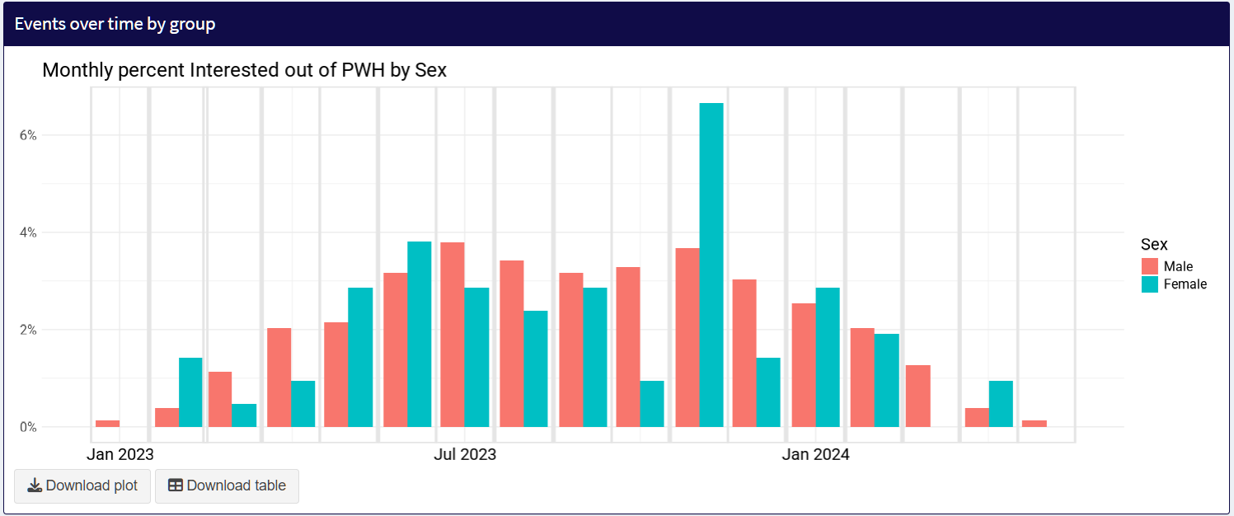
This plot is analogous to the “[indicator] over time by person” plots at the bottom of the LAI ART indicator pages, showing when different events were achieved. However, the plots in the Time Trends page allows for stratification by a chosen demographic/social determinant of health group and zooming in to a specific time period. Note again that these dates reflect the first date when an event occurred.

Data Explorer
The data explorer allows you to dive deeper into your data, by showing LAI ART indicators across two variables at once. There are 4 inputs you can modify.
- Indicator: First, select an indicator of interest from the dropdown list (e.g., counseled).
- Comparison variable: Second, select a comparison variable (e.g., race). This will display stratified bars for each category of that comparison variable (e.g., American Indian or Alaskan Native, Asian, Black, Native Hawaiian or Pacific Islander, White, Other).
- Filter variable: Third, select a filter variable (e.g., age). This will allow you to select specific groups within that variable to filter the data (e.g., only focus on the group ages 24-34 years).
For example, suppose you are interested in comparing the percentage counseled across race categories for clients aged 25-34. You would (1) select “Counseled” as the indicator; (2) select 'Race’ as the comparison variable; and (3) 'Age' as the filter variable, and check off only age group 25-34. The resulting plot would show you the number and percent counseled by race for those aged 25-34, allowing for simple comparison between the groups.
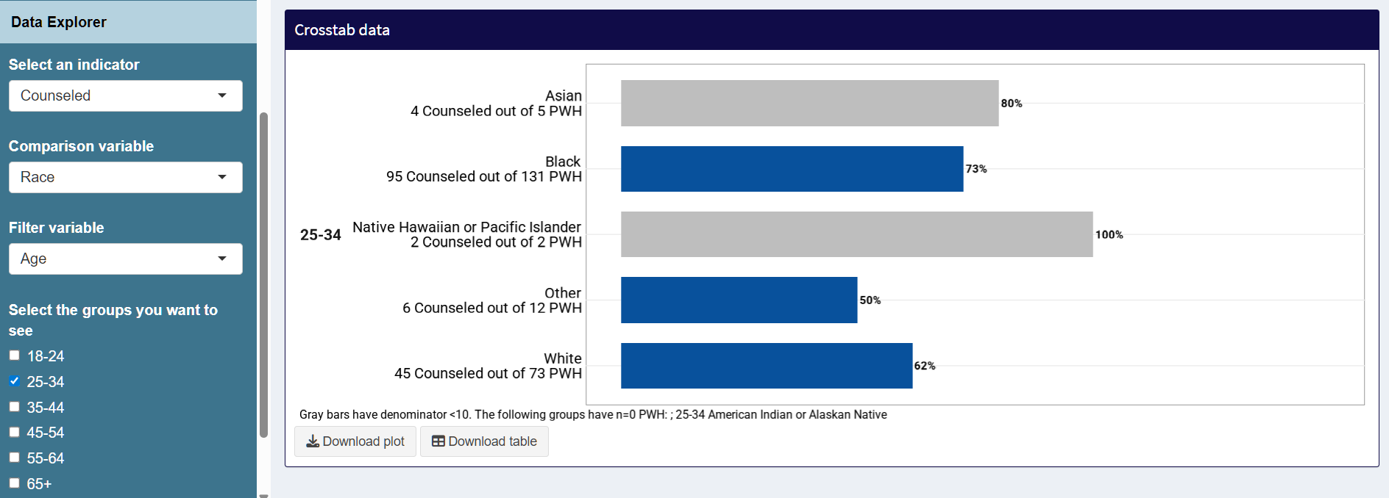
In other words, this plot answers the question: among clients ages 25-34 (filter variable), what percent have been counseled about LAI ART (indicator), by race category (comparison variable).

If ‘Demographics’ is selected as the indicator variable, then the bars will show the distribution of the comparison variable among the group selected via the filter variable. For example, if 'Age' is the comparison variable and 'Sex' is the filter variable, you will see the age distribution by sex.
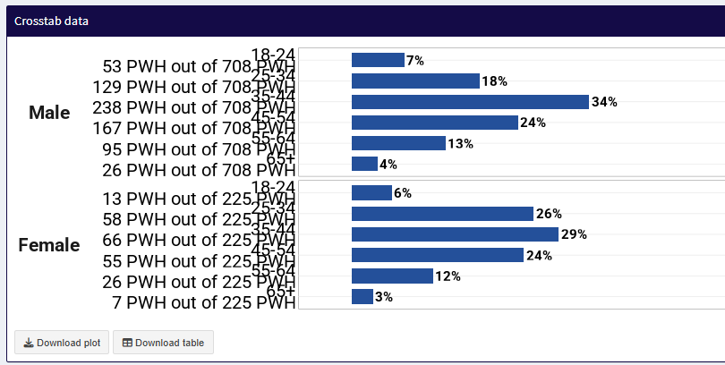

Using Time Trends and Data Explore to monitor Progress on Quality Improvement Initiatives
Clinics can use the Time Trends and Data Explore functionalities to evaluate whether quality improvement initiatives are achieving their intended effects. For example, let’s say a clinic examined their data from time point A to B and identified a care gap in percent of young women who are assessed for LAI ART. In response to this care gap, they start a quality improvement initiative and retrain their staff on how and when to assess patients for LAI ART eligibility and interest and also hold community engagement activities targeted specifically for young women. Now they want to see whether their quality improvement efforts made a difference from time point B to C. To examine changes in time trends, they have two options. Option 1: They can filter the time trend data to include only women, and identify changes over time by age category for women only. This would allow them to see if there are changes to the indicator Assessed in young women relative to older women, after the quality improvement initiative. Option 2: They can filter the time trend data to include only young people, and identify changes over time by sex among young people only. This would allow them to see if there are changes to the indicator Assessed in women relative to men, after the quality improvement initiative.
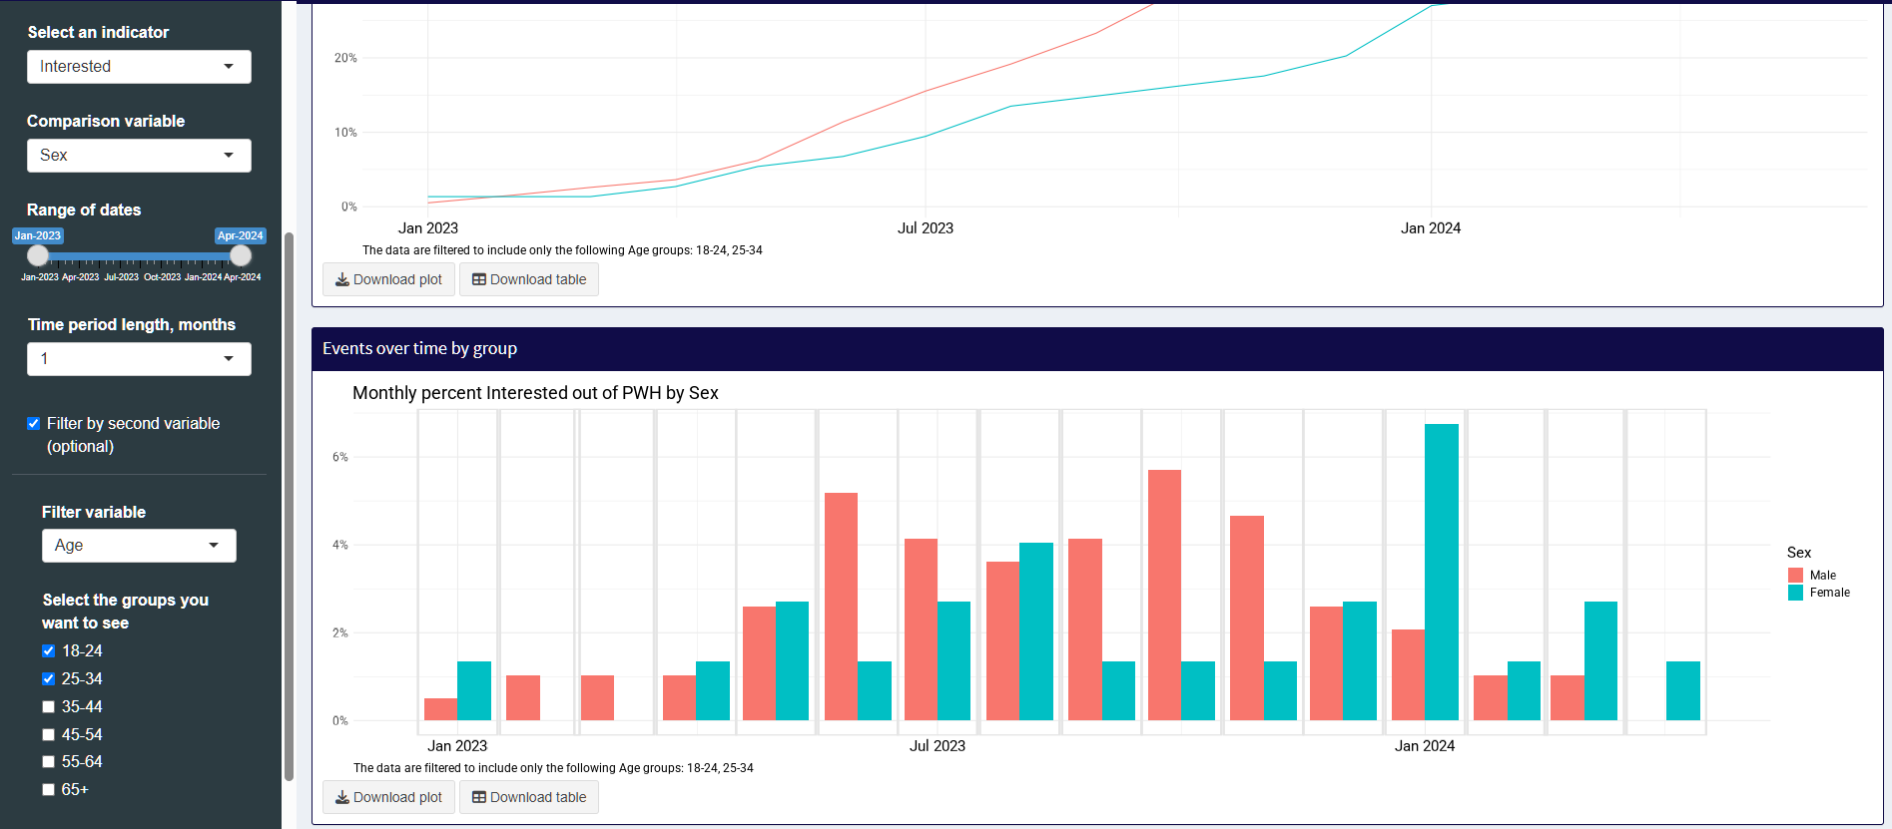
QI initiative
Time C
Time B
Time A

Troubleshooting / FAQs
If you would like additional technical assistance on using the Dashboard, or find that something is not working as intended, please contact us at alai_up@cumc.columbia.edu.
For data related issues, here are some things to consider:
- Completeness. Are the data you are using complete? Does it reflect all clients with HIV at your clinic? Does it include all injections and viral load tests? Are counseling and screening consistently recorded? Missingness in any of these areas could significantly impact the use and interpretation of the Dashboard metrics.
- Accuracy. Are the data you are using accurate? Common problems include injections being coded with the wrong “interval” variable or the wrong date, missing viral load data, missing key demographic variables, and illogical counseling/screening data (e.g. clients marked as ever screened but no screening date or outcome is recorded). Please use the Data Validator to try to address these issues before using the Dashboard.
- Limitations of the Dashboard. The Dashboard was designed for the iCAB/RPV pipeline of assessment (counseling and screening) interested and eligible prescribing initiation sustainment. If your workflow is substantially different from this, it may be challenging to get useful insights from the dashboard.

Why is the percentage of X so low?
Sometimes clinics are surprised to see one of their indicators is very low, typically in the assessment process. This could be for several reasons:
- Client interest may be low
- Few clients may be clinically eligible
- If you only screen clients who are determined to be interested in iCAB/RPV, then the percentage screened may be low.
Please refer to the “outcomes among those assessed” table on the LAI ART overview page for details and insights in this area.

Where are my data going? Are they being stored online? Is the Dashboard secure?
Your data are not leaving your computer. The ALAI UP Dashboard does not store your data in any server, and the data are never sent from your device anywhere else.
When you load the ALAI UP Dashboard webpage, a complete R Programming environment is set up in your browser, with all the necessary packages and files to run the Dashboard. All computations take place within your browser, and the data are deleted when you close the browser tab.
ALAI UP has made best efforts to ensure that these tools are secure. By design, data never leave your computer and are never transmitted over the internet. However, we cannot guarantee security against hackers or other breakdowns in data security. To maintain security of the tools and data, please follow these data security best practices:
- Never share a completed Data Template outside of your organization unless there is an executed Data Use Agreement allowing for the sharing of client-level data and appropriate encryption is used.
- Follow your organization’s best practices for avoiding phishing and other hacking attempts.
The Dashboard is written using the R programming language, using the shiny and shinylive packages. Shinylive is a way to run Shiny entirely in the browser, without any need for a hosted server, using WebAssembly via the webR project. It is deployed via GitHub Pages.
Some security details adapted from this page:
Shinylive allows you to run Shiny applications entirely in a web browser, without the need for a separate server running R.
When an application is deployed with Shinylive, R and Shiny run in the web browser: the browser is effectively both the client and server for the application. There is a web server that serves files, but it does not run R or Shiny—it can be a “dumb” static web server. Here are some features of the system:
- WebAssembly (wasm) is a binary format for compiled programs that can run in a web browser at near-native speeds.
- No installation: No need to install R or Shiny on a computer.
- Easy sharing: Share applications with just a URL.
- Easy deployment: Applications can be deployed to any static web hosting service.
- Easy scaling: Since applications can be served as static files on a “dumb” web server it is easy to scale to high traffic loads.
- Security: Because the code is not running on a server, it eliminates a class of potential security risks. The code runs in the client web browser’s code sandbox, a well-tested platform.

ALAI UP Dashboard (link)
The ALAI UP Dashboard is a web-based tool available at https://dashboard.alai-up.org/.
The Dashboard is a point-and-click program that does not require any programming knowledge or data-sharing to run. The Dashboard program code is written in R software using the shiny package. To make the tool more user friendly, ALAI UP has designed this program to run through standard internet browsers (e.g., Google Chrome, Microsoft Edge, Safari) using the shinylive package. Users interested in running the tool locally through RStudio or other programs may access the code at https://github.com/alai-up/alai_up_local_dashboard. Instructions for doing so are outside of the scope of this guide.
Although the Dashboard program is accessed and run through internet browsers, clinic data are not saved, shared, or uploaded online at any time. Throughout the whole process of using the tool, clinic data stay local to the computer running these programs.

Simulated Dashboard Data
Simulated Dashboard Data are available as an Excel file. It is intended for demonstration purposes, so that users can try out the Dashboard functionality without having to prepare their own data.
The ALAI UP Dashboard Simulated Data are available for download at https://github.com/alai-up/alai_up_local_dashboard/blob/main/data/simulated_data.xlsx

Appendix

Appendix 1. ALAI UP LAI ART Core Indicators and Sub-Indicators
Number of clients with HIV served at clinic
Description | All clients, regardless of age, with HIV with at least one medical visit at your clinic in the reporting period
Rationale | Number of HIV clients is important context to understand the clinic’s HIV treatment services and capacity to scale up new innovations.
Numerator
Denominator | Number of clients served at clinic
Calculation | The number of individuals in the dataset is summed.

Number of clients assessed for LAI ART
Description | The number of clients that were educated and/or screened for LAI ART
Rationale | Depending on workflow considerations, some clinics may choose to counsel first, and then screen for eligibility, or they may choose to screen first and counsel second, or they may do both on the same date. In either case, clinics may choose not to proceed with one assessment phase if the other is not cleared (e.g. they may only counsel those who are deemed clinically eligible). This metric captures the aggregate number of clients assessed for starting iCAB/RPV
Numerator | Number of clients with HIV ever counseled or screened for iCAB/RPV
Denominator | Number of clients with HIV
Calculation | Number of clients with HIV ever counseled or screened for iCAB/RPV divided by the number of clients with HIV.

Number of clients counseled about iCAB/RPV
Description | The number of clients counseled on iCAB/RPV in the reporting period.
Rationale | To determine how clinics are systematically counseling clients about iCAB/RPV. To detect any disparities in how counseling is implemented.
Numerator | Number of clients with HIV ever counseled about iCAB/RPV (icab_rpv_counsel_ever)
Denominator | Number of clients with HIV
Calculation | Number of clients who were ever counseled about iCAB/RPV divided by the number of clients with HIV.

Number of clients interested in switching to iCAB/RPV
Description | The number of clients interested in iCAB/RPV in the reporting period.
Rationale | To determine how many clients that are counseled are interested in iCAB/RPV. Record potential interest or lack of interest so that it can be tracked over time.
Numerator | Number of clients counseled about iCAB/RPV who reported being “Interested” at their most recent counseling event (icab_rpv_counsel_outcome).
Denominator | Number of clients with HIV ever counseled about iCAB/RPV (icab_rpv_counsel_ever)
Calculation | The final indicator only considers the person’s interest level at their most recent appointment where a counseling outcome was reported.

Number of clients screened for iCAB/RPV
Description | The number of clients screened for iCAB/RPV clinical eligibility in the reporting period.  - Is the client >12 years?  - Does the client weigh >35 kg?  Depending on clinic-specific practices the following may apply:  - At last viral load test, was the client virologically suppressed with HIV-1 RNA less than 50 copies per mL?  - Is the client on a stable ART regimen with no history of treatment failure, and with no known or suspected resistance to either cabotegravir or rilpivirine?
Rationale | To determine how clinics are systematically reviewing EMR to determine eligibility. To detect any disparities in how screening is implemented.
Numerator | Number of clients with HIV ever screened for iCAB/RPV clinical eligibility (icab_rpv_screen_ever)
Denominator | Number of clients with HIV
Calculation | Number of clients who were ever screened about iCAB/RPV divided by the number of clients with HIV.

Number of clients with HIV clinically eligible for iCAB/RPV
Description | The number of clients >12 years; weighing >35 kg; are virologically suppressed (HIV-1 RNA less than 50 copies per mL); and on a stable ART regimen with no history of treatment failure and with no known or suspected resistance to either cabotegravir or rilpivirine.  Please note that eligibility criteria may vary by clinic. In particular, some clinics may consider those not virally suppressed to be clinically eligible while others may not. Some clinics may consider those with a history of treatment failure to be eligible while others may not. Use criteria most relevant to your site to code this variable.
Rationale | To determine how many people of those screened for iCAB/RPV who are clinically eligible to initiate on iCAB/RPV.
Numerator | Number of clients with HIV clinically eligible for iCAB/RPV (icab_rpv_screen_outcome)
Denominator | Number of clients with HIV ever screened about iCAB/RPV (icab_rpv_screen_ever)
Calculation | The final indicator only considers the person’s eligibility at their most recent screening event.

Number of clients interested and eligible for iCAB/RPV
Description | The number of clients that were interested and eligible for iCAB/RPV
Rationale | To determine how many people who were assessed for iCAB/RPV were both interested in initiating and clinically eligible for iCAB/RPV. This gives a baseline for how many clients could initiate iCAB/RPV at the clinic.  Note that anyone that is prescribed or initiated on iCAB/RPV is labeled as “interested and eligible” to help maintain consistent numerators and denominators.
Numerator | Number of clients with HIV interested and eligible for iCAB/RPV at their most recent counseling and screening events.
Denominator | Number of assessed for iCAB/RPV
Calculation | Number of clients interested and eligible for iCAB/RPV divided by the number of clients assessed for iCAB/RPV.

Number of clients prescribed iCAB/RPV
Description | The number of clients prescribed iCAB/RPV in the reporting period.
Rationale | To capture the relationship between those screened for iCAB/RPV and those prescribed, as well as how many people are prescribed iCAB/RPV but are unable to initiate due to insurance barriers.  Note that anyone that is prescribed is labeled as “interested and eligible”, and anyone who is initiated on iCAB/RPV is labeled as “prescribed” to help maintain consistent numerators and denominators.
Numerator | Number of clients prescribed iCAB/RPVs by clinical provider (icab_rpv_rx)
Denominator | Number of clients with HIV interested and eligible for iCAB/RPV at their most recent counseling and screening events (if counseling and screening is consistently recorded)  OR  Number of clients served at clinic (if counseling and screening is NOT consistently recorded)
Calculation | Number of clients prescribed iCAB/RPV divided by the relevant denominator

Number of clients initiated on iCAB/RPV
Description | Total number of clients who were initiated on iCAB/RPV during the reporting period
Rationale | Monitor total number of clients who have ever received a dose of iCAB/RPV in comparison to clinic’s total population and to those prescribed  Note that anyone who is initiated on iCAB/RPV is labeled as “prescribed” to help maintain consistent numerators and denominators.
Numerator | Number of clients initiated on iCAB/RPV (icab_rpv_shot1_date)
Denominator | Number of clients prescribed iCAB/RPVs by clinical provider (icab_rpv_rx)
Calculation | The indicator is equal to the number of clients with at least 1 iCAB/RPV injection divided by the number of clients prescribed iCAB/RPV

Number of clients with HIV who are sustained on iCAB/RPV
Description | The number of clients who were currently on iCAB/RPV at the clinic as of the most recent data extract.
Rationale | Important to understand whether clients discontinue iCAB/RPV, and when and why they do so. Discontinuation is not by itself a bad outcome, hence different reasons  Note that clients who stop and restart iCAB/RPV should have icab_rpv_discontinued be ‘0’ for ‘sustained’. Persons on iCAB/RPV who switch to another clinic should be considered discontinued for the purposes of this tracker.
Numerator | Number of clients initiated on iCAB/RPV who have not discontinued (icab_rpv_discontinued is ‘0’ or blank) as of the most recent data extract.
Denominator | Number of clients initiated on iCAB/RPV (icab_rpv_shot1_date)
Calculation | Numerator / Denominator  Note that if a person on iCAB/RPV has had greater than 90 days since their previous injection with no subsequent injection, they are considered “discontinued”

LAI Clinical Outcomes
Number of early, on time, and late injections
Description | The number of follow-up (not loading dose or first dose) injections that are administered on time (+/- 7 days of target treatment date) based on previous injection dose type.
Rationale | Important to understand iCAB/RPV treatment adherence, both from the client and clinic program perspective
Numerator | Number of follow up iCAB/RPV doses with on time (+/- 7 days) receipt of injection (icab_rpv_shotX_date). Target of 31 days for monthly and 62 days for bimonthly (Dashboard allows for changing to 28 days and 56 days).
Denominator | Number of follow-up iCAB/RPV doses administered. First injections or injections with late exception indicated are not included.
Calculation | This variable is calculated based on the previous interval given (icab_rpv_shot[X-1]_interval) and the date relative to the previous dose (icab_rpv_shotX_date).  - The time between injections is calculated as the number of days between injections, unless the injection is a reloading dose or the client is coming from another clinic (icab_rpv_shotX_late_exception = 1)  - A dose is considered late if any of the following is true:  - The previous injection had an interval of 1 and the time between injections is greater than 38 days  - The previous injection had an interval of 2 and the time between injections is greater than 69 days  - A dose is considered early if any of the following is true:  - The previous injection had an interval of 1 and the time between injections is less than 24 days  - The previous injection had an interval of 2 and the time between injections is less than 55 days  - A dose is considered on time if it is neither late nor early, or if it is late by interval but oral bridging was used during that time period.

Number of clients with HIV who are virally suppressed prior to iCAB/RPV initiation (pre-iCAB/RPV VL)
Description | Viral suppression is measured as a viral load test result of <200 copies/mL at the most recent viral load test prior to iCAB/RPV initiation.
Rationale | A key goal of HIV treatment services is to improve viral suppression – it’s important to capture baseline viral load for clients initiating iCAB/RPV to see how their viral load might change over time.
Numerator
Denominator
Calculation | If the variable hiv_vl_pre_icab_result is specified, that value is used as the pre-iCAB/RPV Viral load.  If it is not specified, then the closest viral load test result (hiv_vl_X_result) to iCAB/RPV initiation (icab_rpv_shot1_date) is used. The viral load test date (hiv_vl_X_date) must be within 90 days before to 2 weeks after iCAB/RPV initiation to be used as the pre-iCAB/RPV viral load.  If neither of the above criteria are met, then pre-iCAB/RPV viral load is considered missing.

Time to first viral suppression for those with elevated pre-iCAB/RPV viral load
Description | A statistical estimate of the percentage of clients achieving a suppressed viral load (<50 or <200 copies/mL) at different time points.
Rationale | To assess if clients initiating iCAB/RPV with viremia achieve viral suppression, and how quickly they do so.  Note that these are estimates only, not exact percentages, because the calculation accounts for differential follow-up times.
Numerator | Time of first viral load below chosen threshold, or last time on iCAB/RPV.
Denominator | Persons who initiated iCAB/RPV and have a valid pre-iCAB/RPV viral load result above the chosen threshold (≥50 or ≥200 copies/mL).
Calculation | The calculation uses a Kaplan-Meier survival estimator.  The ‘event’ is the first viral load under the chosen threshold. If no event occurs, the individual is considered censored, as per standard survival analysis methods.  The ‘time’ is the earlier of the time in days (relative to the first injection) of the first viral load under the chosen threshold, or the last time on iCAB/RPV available.  The estimates are extracted at 0, 60, 120, 180, and 360 days from iCAB/RPV initiation.

Time to first elevated viral load above threshold
Description | A statistical estimate of the percentage of clients having an elevated viral load (≥50 or ≥200 copies/mL) at different time points.
Rationale | To assess if clients on iCAB/RPV maintain consistent viral suppression.  Note that these are estimates only, not exact percentages, because the calculation accounts for differential follow-up times.
Numerator | Time of first viral load above chosen threshold, or last time on iCAB/RPV.
Denominator | Persons who initiated iCAB/RPV, have a valid pre-iCAB/RPV viral load result, and either initiated with a suppressed viral load or achieved a suppressed viral load while on iCAB/RPV.
Calculation | The calculation uses a Kaplan-Meier survival estimator.  The ‘event’ is the first viral load above the chosen threshold. If no event occurs, the individual is considered censored, as per standard survival analysis methods.  The ‘time’ is the earlier of the time in days (relative to the first suppressed viral load) of the first viral load above the chosen threshold, or the last time on iCAB/RPV available.  The estimates are extracted at 0, 60, 120, 180, and 360 days from the suppressed viral load.

Time to first treatment failure
Description | A statistical estimate of the percentage of clients having viral failure at different time points.
Rationale | To assess if clients on iCAB/RPV maintain consistent viral suppression.  Treatment failure is defined as 1 viral load ≥1000 or 2 consecutive viral loads ≥200 copies/mL or emergent viral resistance  Note that these are estimates only, not exact percentages, because the calculation accounts for differential follow-up times. Also, note that this metric could be biased if you have many clients lost to follow-up on iCAB/RPV. Those clients would be considered ‘censored’ rather than having treatment failure, even though in reality they could still have (unmonitored) treatment failure.
Numerator | Time of first treatment failure, or last time on iCAB/RPV.
Denominator | Persons who initiated iCAB/RPV, have a valid pre-iCAB/RPV viral load result, and either initiated with a suppressed viral load or achieved a suppressed viral load while on iCAB/RPV.
Calculation | The calculation uses a Kaplan-Meier survival estimator.  The ‘event’ is the first treatment failure, defined as 1 viral load ≥1000 or 2 consecutive viral loads ≥200 copies/mL or emergent viral resistance. If no event occurs, the individual is considered censored, as per standard survival analysis methods.  The ‘time’ is the earlier of the time in days (relative to the first suppressed viral load) of the first treatment failure, or the last time on iCAB/RPV available.  The estimates are extracted at 0, 60, 120, 180, and 360 days from the suppressed viral load.

Periodic clinic-level most recent viral load
Description | An aggregate estimate of the percentage of clients virally suppressed within each selected time period
Rationale | To assess if viral suppression at the clinic is increasing or decreasing over time. The threshold for viral suppression can be selected as <50 copies/mL or <200 copies/mL. The time periods can be every 3 months, every 6 months, or every 12 months. Stratified by iCAB/RPV receipt in period.  Note that, while each person can only contribute 1 viral load result during each period, that does not mean that each person appears in every period. In fact, the population of people in each period can vary widely; it solely depends on who received a viral load test during that period.
Numerator | Persons with viral load test result below threshold
Denominator | Persons with viral load test results in a given period of time.
Calculation | Excludes those that are within 6 months of diagnosis. Count and percentage are both available. Careful attention should be paid to the count of persons with viral load tests in each period, as it heavily influences the generalizability of any comparisons.

